ASSIGNMENT – 9

Q1. Write a query that lists each order number followed by the name of the customer who made the order.
Ans-

select ONUM, CNAME FROM ORDERS LEFT JOIN CUSTOMERS ON (ORDERS.CNUM= CUSTOMERS.CNUM);
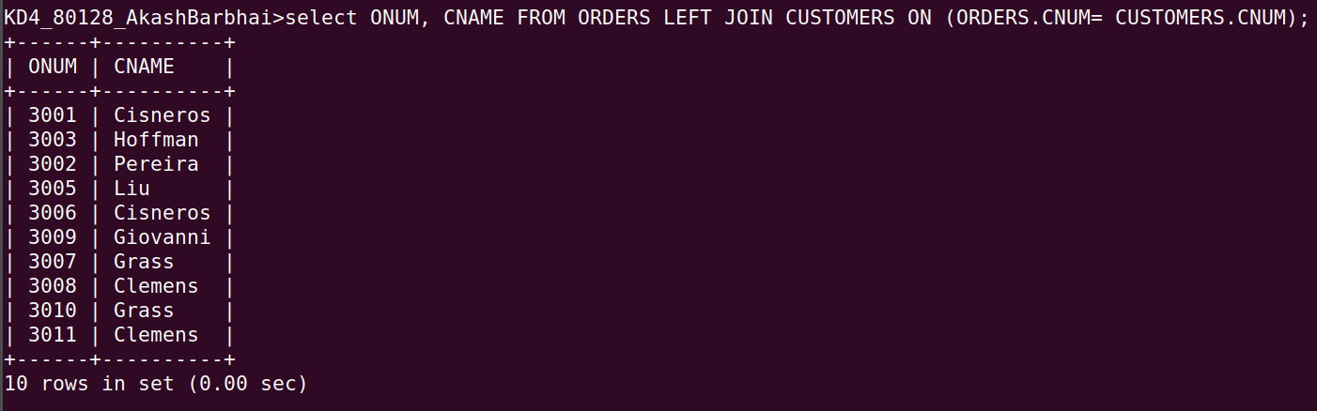

Q2. Write a query that gives the names of both the salesperson and the customer for each order along with the order number.
Ans-

select Sname, Cname, Onum from CUSTOMERS, ORDERS, SALESPEOPLE where SALESPEOPLE.Snum = CUSTOMERS.Snum AND SALESPEOPLE.snum = ORDERS.Snum
ORDER BY 1,2;
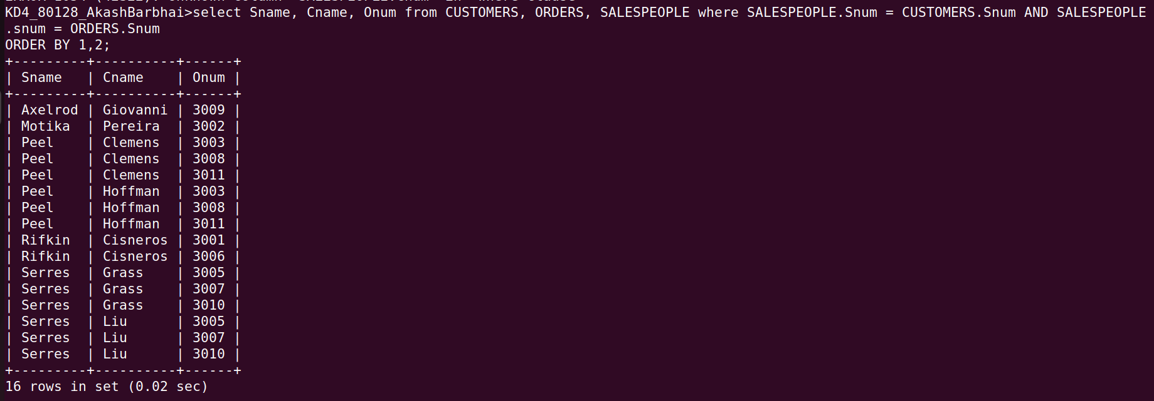

Q3. Write a query that produces all customers serviced by salespeople with a commission above 12%. Output the customer's name, the salesperson's name, and the salesperson's rate of commission.
Ans-

SELECT CNAME, SNAME, COMM
FROM CUSTOMERS, SALESPEOPLE
WHERE SALESPEOPLE.SNUM = CUSTOMERS.SNUM
AND COMM > 0.12;

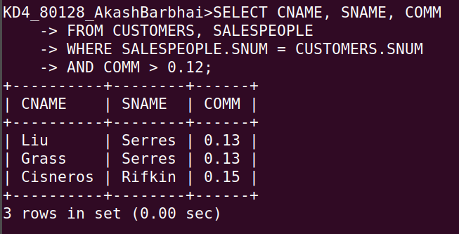

Q4. Write a query that calculates the amount of the salesperson's commission on each order by a customer with a rating above 100.
Ans-
SELECT ONUM, AMT*COMM COMMISSION
FROM ORDERS, CUSTOMERS, SALESPEOPLE
WHERE SALESPEOPLE.SNUM = ORDERS.SNUM
AND RATING > 100;
