ASSIGNMENT 7

Q1) write query that counts all orders from October 3?

Ans-

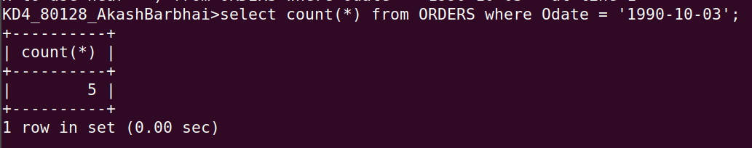

Q2) write the query that counts the number of different non-NULL city in the Customers table?

Ans-

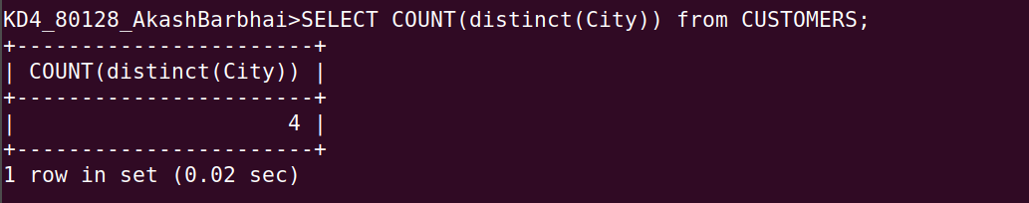

Q3) write a query that selects each customers smalest order?
Ans-

SELECT Cnum, min(Amt) from ORDERS GROUP BY Cnum;

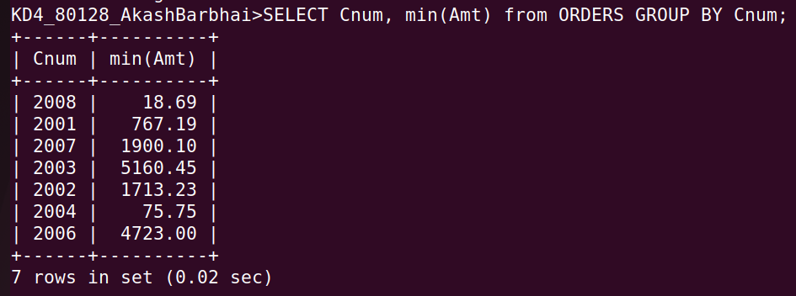

Q4) Write a query that selects the first customer in a aplhabetical order, whose name begins with G?
Ans- select min(cname) from CUSTOMERS
-> where substr(cname,1,1) = 'G'
-> order by Cname;

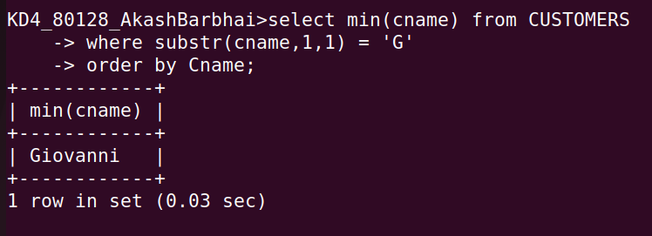

Q5) Write a query that selects the highest rating in each city?
Ans
select city,max(Rating) from CUSTOMERS group by city;
-
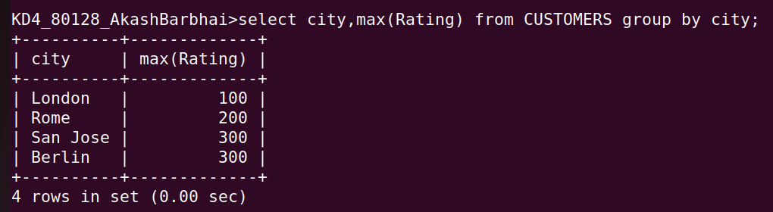

Q6) Write a query that counts the name of salespeople regestrating order for each day?

Ans-

