ASSIGNMENT 5

Q1) Write a query that will give you all orders for more than Rs,. 1,000.

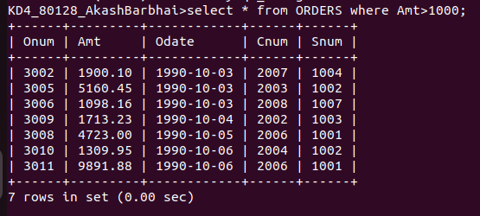

Q2) write a query that will give you the names and cities of all salespeople in london with a commision .10.

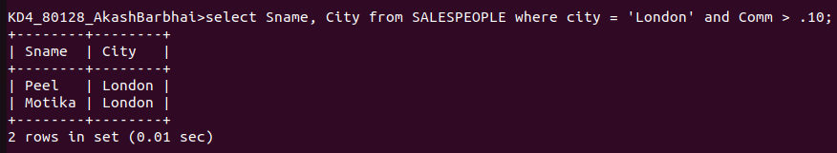
Q3)write a query on the Customers table whose output will exclude all customers with the rating <= 100, unless they are located in rome.

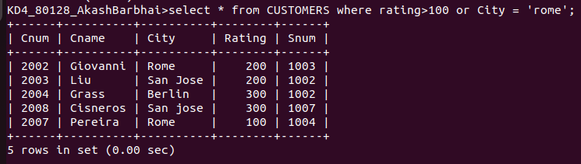

Q4) what will be the output of the following query?
Select * from Orderswhere (amt<1000 ORNOT (odate = ‘1990-10-03‘ AND cnum >2003));
Ans-

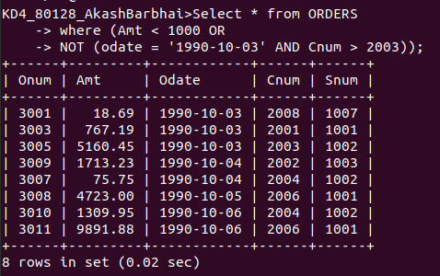

Q5) what will be the output of the following query?
Select * from Orders where NOT ((odate = ‘1990-10-03’ OR snum>1006) AND amt >= 1500);
Ans-

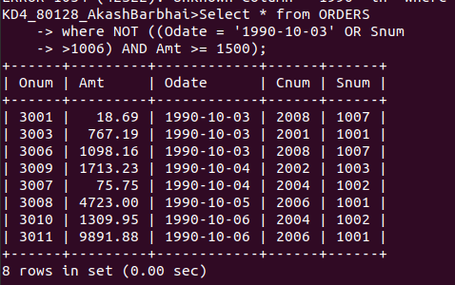

Q6) What is the simpler way to write this query?
Select snum, sname, city, comm From Salespeople where (comm > .12 OR comm <.14);
Ans-

