ASSIGNMENT 4

etrieving Information from Tables.

1) Write a select command that produces the order number, amount, and date for all rows in the Orders table.

ANS- select Onum, Amt, Odate from ORDERS;

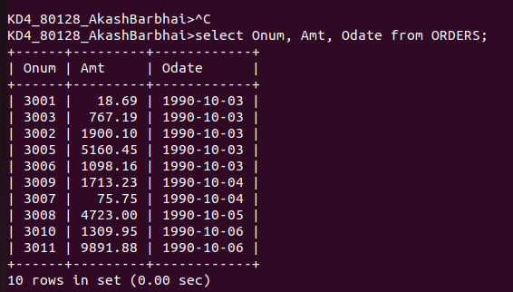

2) Write a query that produces all rows from the Customers table for which the salesperson's number is 1001.
ANS-
select Onum, Amt, Odate, Cnum, Snum from ORDERS where Snum = 1001;

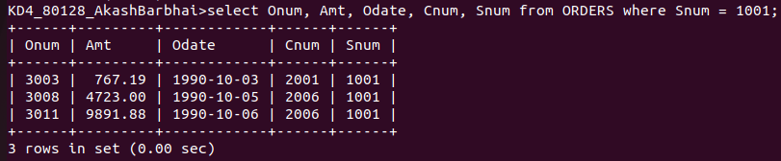

Q3) Write a query that displays the Salespeople le with the columns in the following order: city, sname, snum, comm.

Ans- select CITY, SNAME, SNUM, COMM from SALESPEOPLE;

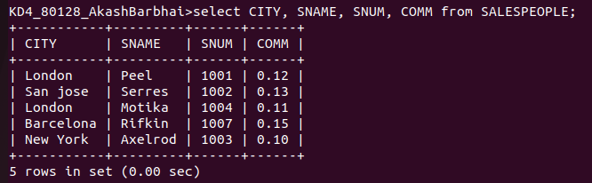

Q4) Write a select command that produces the rating followed by the name of each customer in San Jose.

ANS- AkashBarbhai>SELECT CNAME, Rating FROM CUSTOMERS WHERE CITY='san Jose';

