SQL ASSIGNMENT -1

Question- Creating sample tables and inserting values. Create the following tables with the given structures and insert sample data as specified:

A) SALESPEOPLE

Snum int (4)
Sname varchar (10)
City varchar (10)
Comm float(3,2)

Ans- create table SALESPEOPLE (Snum int(4), Sname varchar(10), City varchar(10), Comm float(3,2));

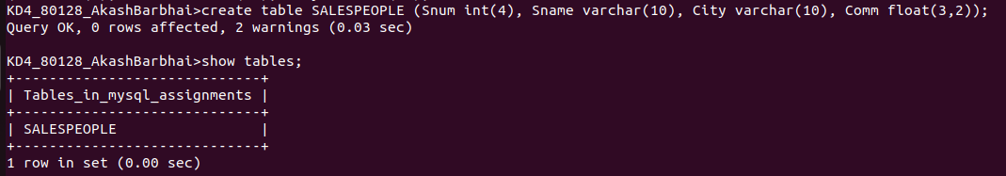
B) CUSTOMERS

Cnum int (4)
Cname Varchar (10)
City Varchar(10)
Rating Varchar (10)
Sname int(4)

Ans- create table CUSTOMERS (Cnum int(4), Cname varchar(10), City varchar(10), Rating int(4), Snum int(4));
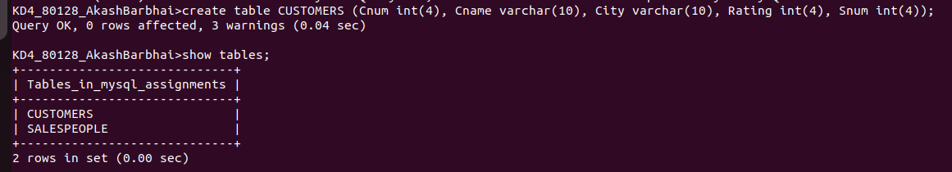
C) ORDERS
Onum int(4)
Atm float(7,2)
Odate date
Cnum int(4)
Snum int(4)

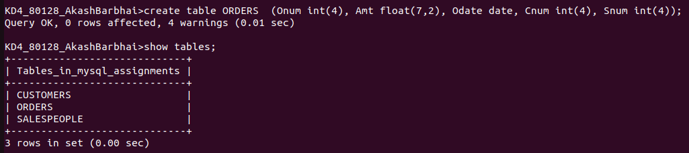
After putting data in table of SALESPEOPLE
Ans-
insert into SALESPEOPLE Values('1001', 'Peel', 'London', .12),
-> ('1002', 'Serres', 'San jose', .13),
-> ('1004', 'Motika', 'London', .11),
-> ('1007', 'Rifkin', 'Barcelona', .15),
-> ('1003', 'Axelrod', 'New York', .10);

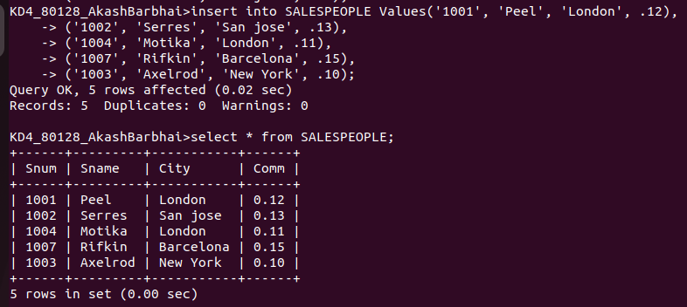
After putting data of Customers-

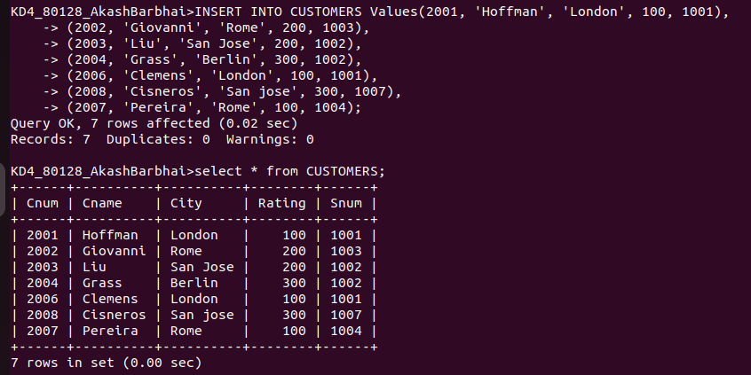

putting data of Orders-

insert into CUSTOMERS Values (3001, 18.69, '03-OCT-1990', 2008, 1007),
-> (3003, 767.19, '03-OCT-1990', 2001, 1001),
-> (3002, 1900.10, '03-OCT-1990', 2007, 1004),
-> (3005, 5160.45, '03-OCT-1990', 2003, 1002),
-> (3006, 1098.16, '03-OCT-1990', 2008, 1007),
-> (3009, 1713.23, '04-OCT-1990', 2002, 1003),
-> (3007, 75.75, '04-OCT-1990', 2004, 1002),
-> (3008, 4723.00, '05-OCT-1990', 2006, 1001),
-> (3010, 1309.95, '06-OCT-1990', 2004, 1002),
-> (3011, 9891.88, '06-OCT-1990', 2006, 1001);

