1. Write a command that puts the following values, in their given order, into the salespeople table: city-San Jose, name-Blanco, comm-NULL, Snum-1100.

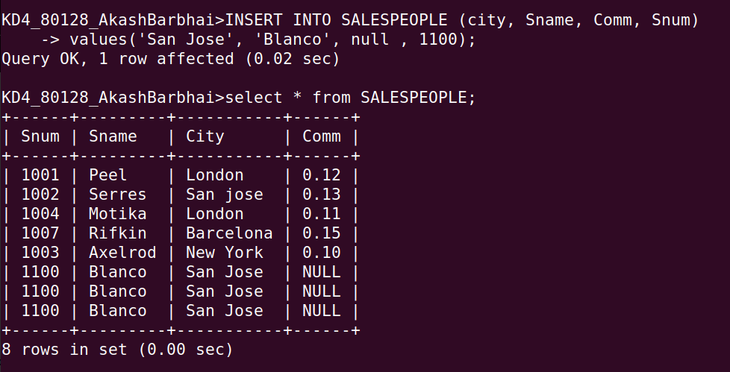
2. Write a command that removes all orders from customer
Clemens from the orders table.
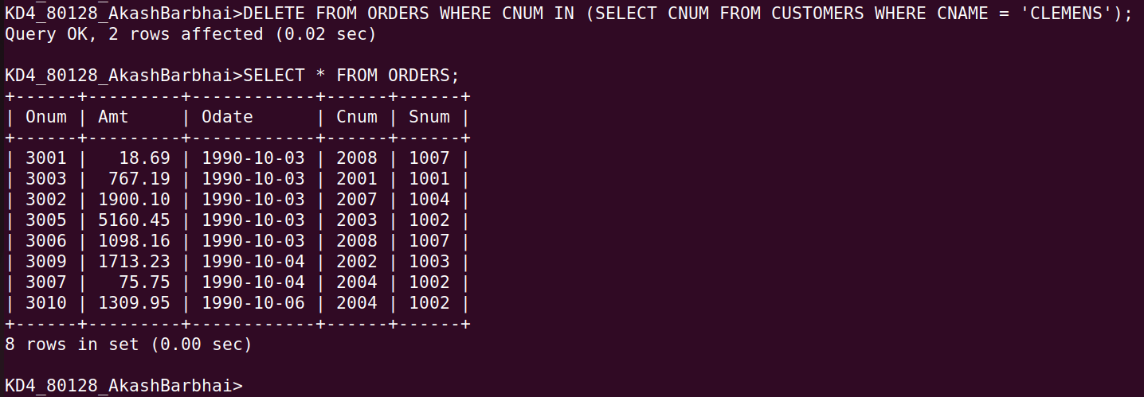

Q3 Write a command that increases the rating of all customers in Rome by 100;

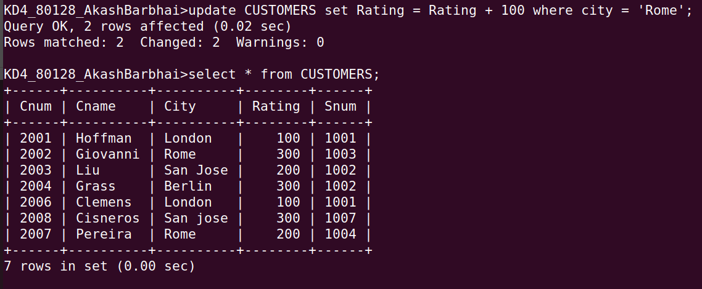
Q4 Salesperson Serres has left the company. Assign hercustomers to Motika.

