ASSIGNMENT-8

Q1) Assume each salesperson has a 12% comission. Write a query on the orders table that will produce the order number, The salesperson’s number, and the amount of salesperson’s comission for that order?
Ans-
SELECT Onum, Snum, Amt*.12 From ORDERS;

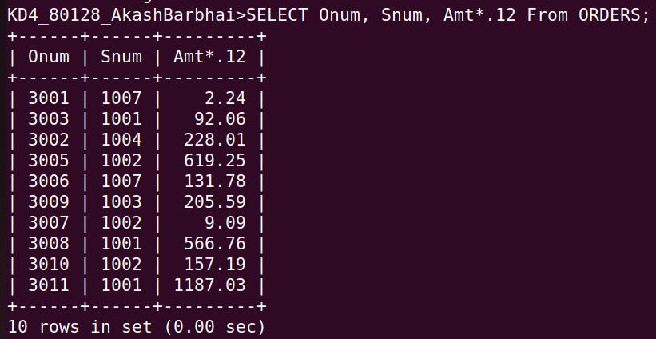

Q2) Write a query on a customers table that will find the highest rating in each city,Put the output in this form?
Ans- select concat('For the city ', Concat(City, concat('the highest rating is : ', max(Rating))))from CUSTOMERS group by City;

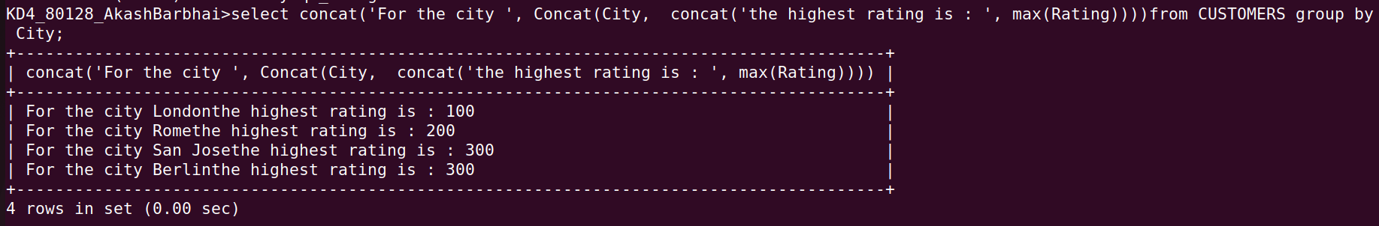

Q3) Write the query that lists customers descending order of rating. Output rating field first, followed by the customer’s name and numbers?
Ans-
SELECT Rating, Cname, Cnum FROM CUSTOMERS ORDER BY Rating desc;

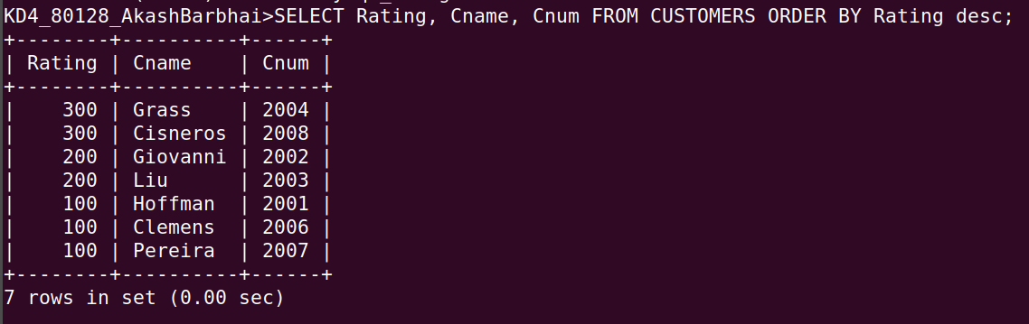
Q4) Write a query that totals the orders for each day and places the results in descending order?
Ans-

select Odate, Count(Onum) from ORDERS
GROUP BY Odate
ORDER BY 2 desc;

