ASSIGNMENT-6

Q1) Write two different queries that would produce all orders taken on October 3 th or 4 th, 1990?
SOLLUTION 1
Ans. select Onum from ORDERS where Odate between '1990-10-03' AND '1990-10-04';

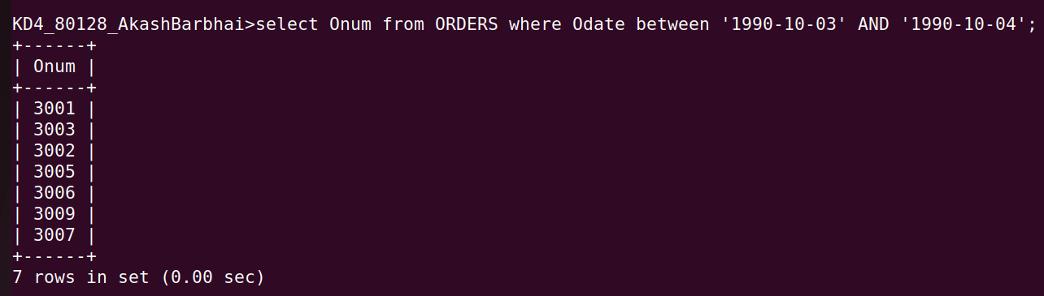

SOLLUTION 2

Ans. select Onum from ORDERS where Odate IN ('1990-10-03','1990-10-04');

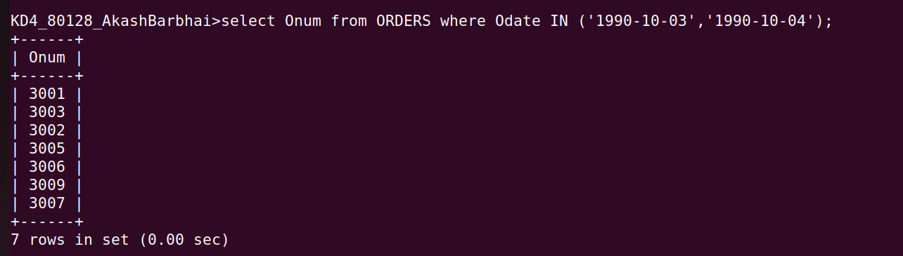

Q2) Write all query that select all of the customers serviced by Peel or Motika?

ANS. select Cname from CUSTOMERS where Snum IN (1001,1004);

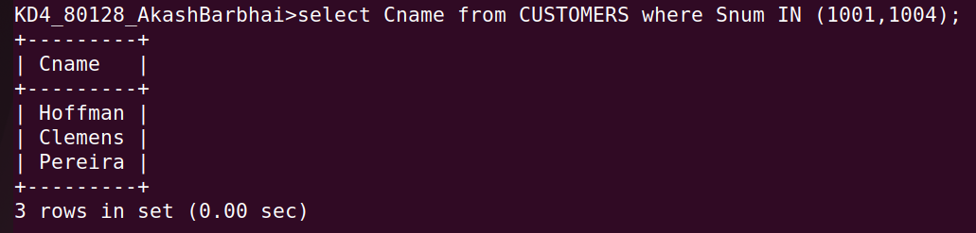

OR

select Cname from CUSTOMERS where Snum IN ((select Snum from SALESPEOPLE where Sname IN ('Peel')),(select Snum from SALESPEOPLE where Sname IN ('Motika')));
Ans-

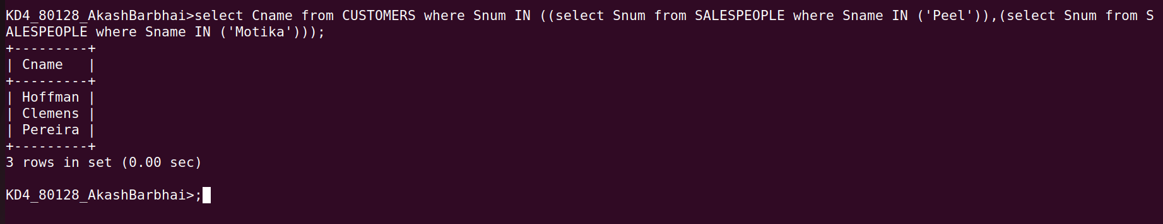

Q3) Write a query that will produce all the customers whose names begin whose name begin with a letter from ‘A’ to ‘G’?

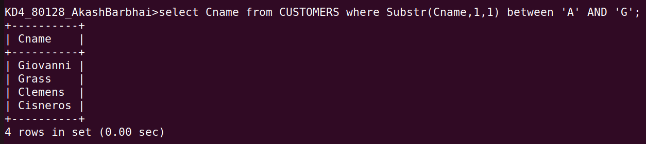
Ans. select Cname from CUSTOMERS where Substr(Cname,1,1) between 'A' AND 'G';

Q4)Write a query that selects all customers whose names begin with letter ‘C’

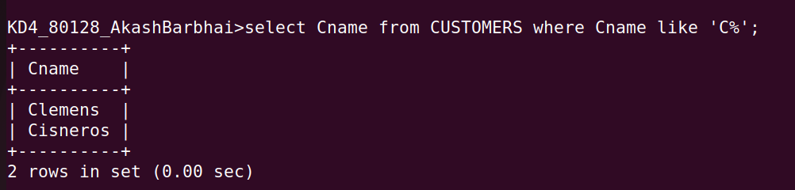
Ans.

Q5) Write a query that selects all orders except those with zeros or null in the atm field?

Ans.

