ASSIGNMENT 12

Q1) Write a query that selects all customers whose ratings are equal to or greater than ANY of Serres'.
ANS-

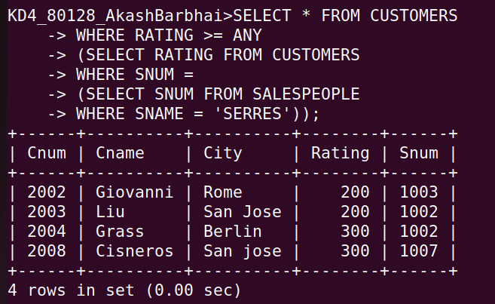

2) Write a query using ANY or ALL that will find all salespeople who have no customers located in their city.
ANS-

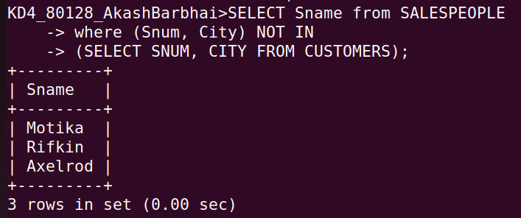

3) Write a query that selects all orders for amounts greater than any for the customers in london.
ANS-

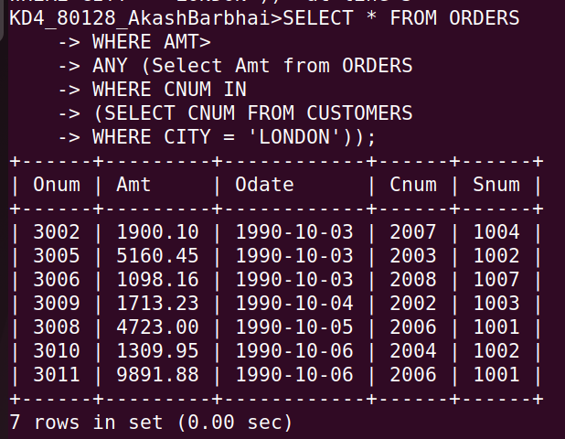

4) Write the above query using MIN or MAX.
ANS-

