Assignment – 6

1. Write two different queries that would produce all orders taken on october 3rd and 4th , 1990.
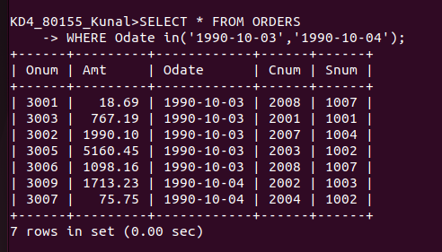

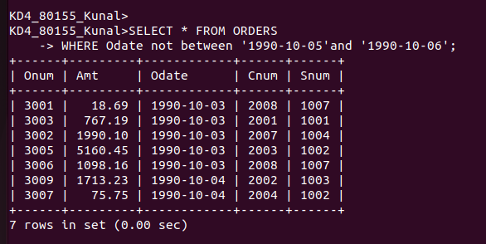

2. Write query that selects all of the customers serviced by peel or motika. (Hint: the Snum field relates the two tables to one another).

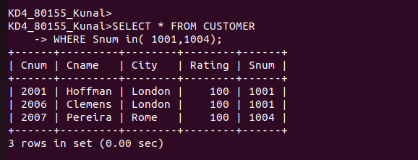

3. Write a query that will produce all the customers whose names begin with a letter from ‘A’ to ‘G’

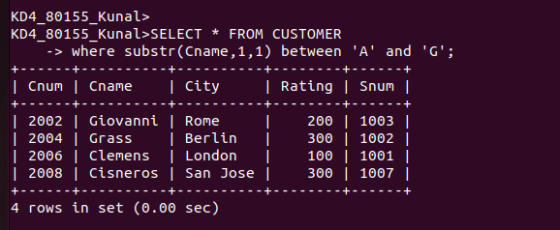

4. write a query that selects all customers whose names begin with the letter ‘C’.

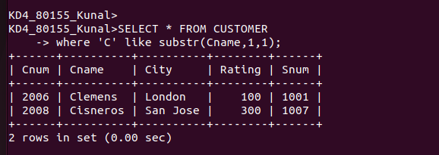

5. Write a query that select all orders except those with zeroes or Null in the amt field.

