ASSIGNMENT-8

1. Assume each salesperson has a 12% commission. Write a query on the orders table that will produce the order number, the salesperson number,
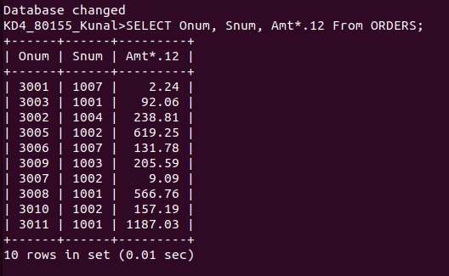
and the amount of the salesperson’s commsion for that order.

2. write a query on the customer table that will find the highest rating in each city. Put output in this format:

For the city(City) , the highest rating(rating).

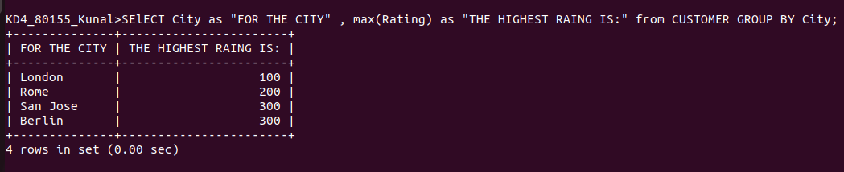
3. Write a query that lists customers in descending order of rating. Output the rating field first, followed by the customer’s name and number.

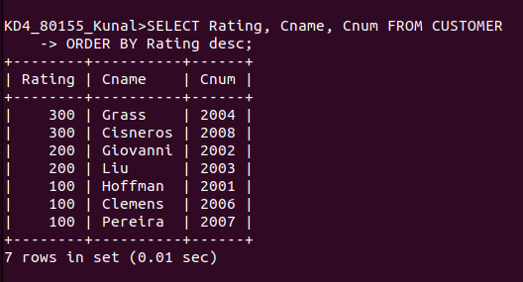

4. Write a query that totlas the orders for each day and places the result in descending order.

