Assignment- 4

1. Write a select command that produces the orders number, amount, and date for all rows in the orders table.

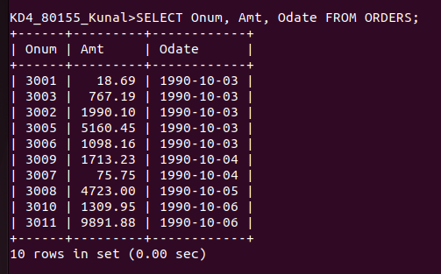

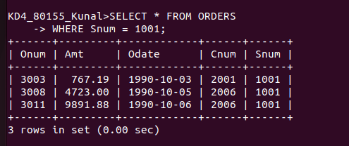
2. Write a query that produces all row from the customers table for which the salesperson’s number is 1001.

3. Write a query that displays the salespeople table with the columns in the following orders: City, Sname, Snum, Comm

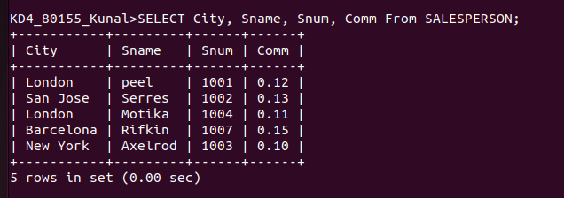

4. Write a select command that produecs the rating followed by the name of each customer in san jose.

