Assignment – 7

1. Write a query that counts all orders for october 3.

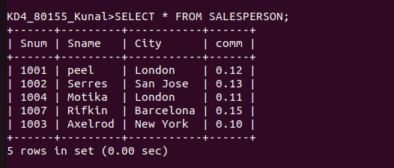
2. Write a query that counts the number of differnet non-null city values in the customers table.
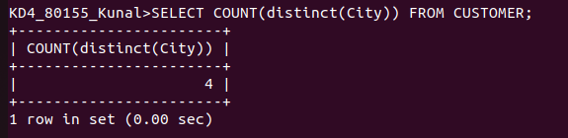
3. Write a query that selects each customer’s smallest order.

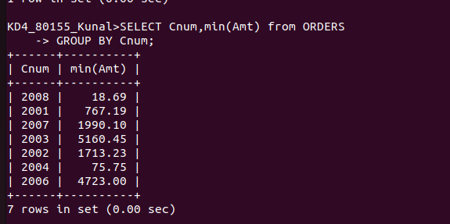

4. Write a query that selects the first customer in alphabetical order, whose name beigns with G.
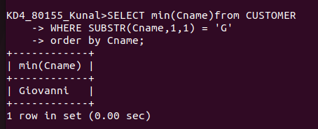

5. Write a query that selects the highest rating in each city.

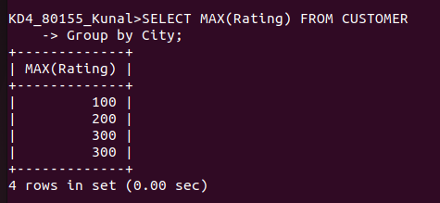

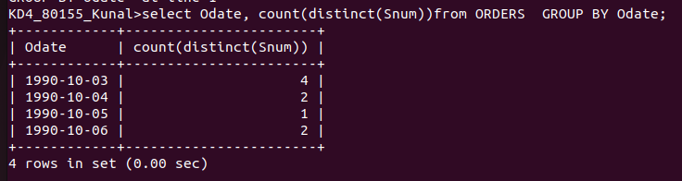
6. Wriet a query that counts the number of salesperson registering orders for each day. (If a salesperson has more than one order on a givenday, he or she should be counted only once.).

