Assignment-14

1.Write a command that puts the following values, in their given order, into the salespeople table: city- San jose, name- Blanco, Comm – NULL,
cnum-1100.

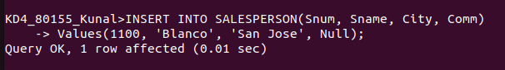

2. Write a command that removes all orders from customer clemens from the orders table.

3. Write a command that increases the rating of all customers in Rome by 100.
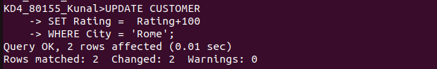
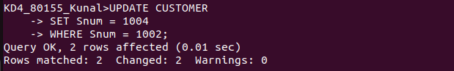
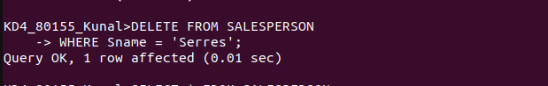
4. Salesperson serres has left the company. Assign her customers to motika.

