Assignment – 5

1. Write a query that will give you all ordes for more than RS. 1,000

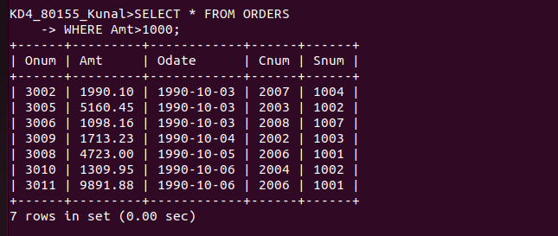

2. Write a query that will give you the names and cities of all salesperson in london with a comission above .10.

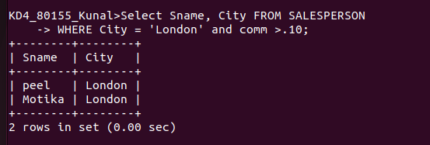

3. Write a query on the customer table whose output will exclude all customers with a rating <=100, unless thet are located in rome.

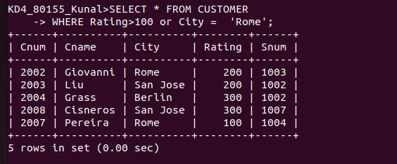

4. What will be the output from the following query ?

SELECT * FROM ORDERS
WHERE (Amt <1000 or
NOT (Odate = ‘1990-10-03 And Cnum > 2003’));

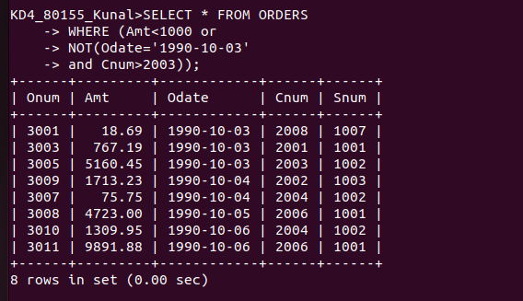

5. What will be output of the following query ?

SELECT * FROM ORDERS
WHERE NOT((Odate =’1990-10-03’ Or Snum>1006) And Amt >=1500);

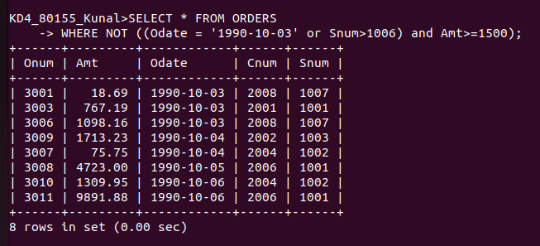
6. What is a simpler way to write this Query?

SELECT Snum, Sname, City, Comm FROM SALESPERSON
WHERE (Comm > .12 Or Comm < .14)

