Assignment – 12

1. Write a query that selects all customer whose ratings are equal to or greater than any of Serres.

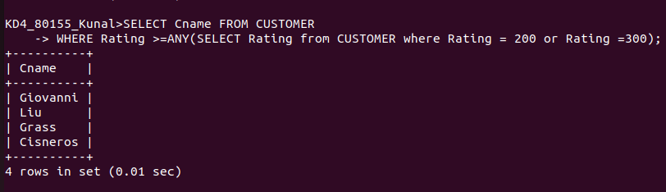
2. Write a query using ANY or ALL that will find all salesperson in their city.

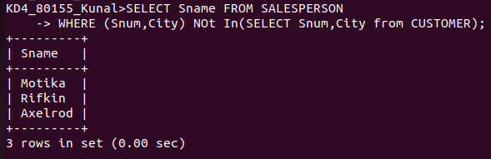
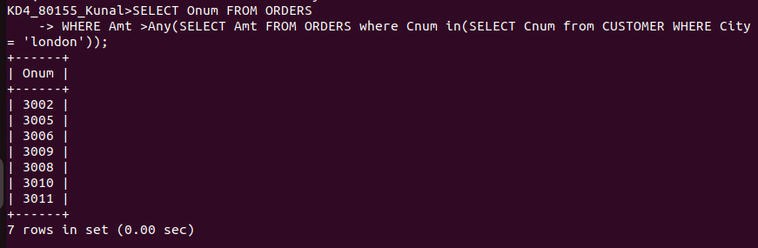
3. Write a query that selects all orders for amounts greaeter than any for the customers in london.

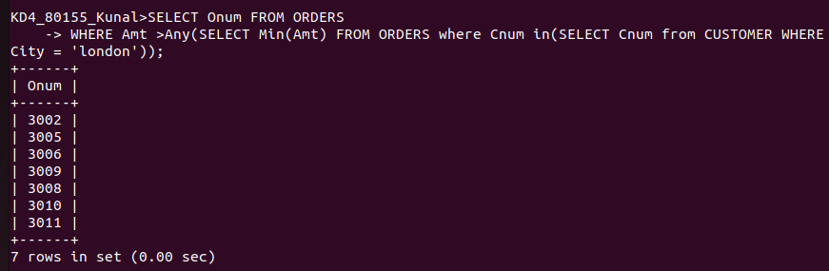
4. Write the above query using MIN or MAX.

