Name -Kunal Markam
Rollno - 80155
Group – KD4
Linux Shell Script Assignment – 3

1)Write a shell script to display your LOGIN NAME and HOME directory.

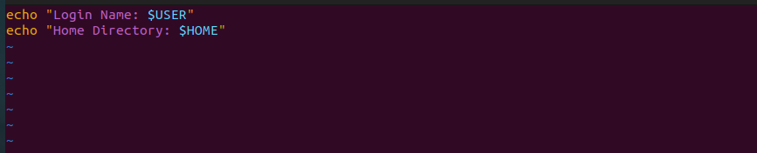

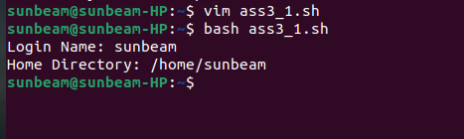

2)Write a shell script to display menu like “1. Date, 2. Cal, 3. Ls, 4. Pwd, 5. Exit” and execute the commands depending on user choice.

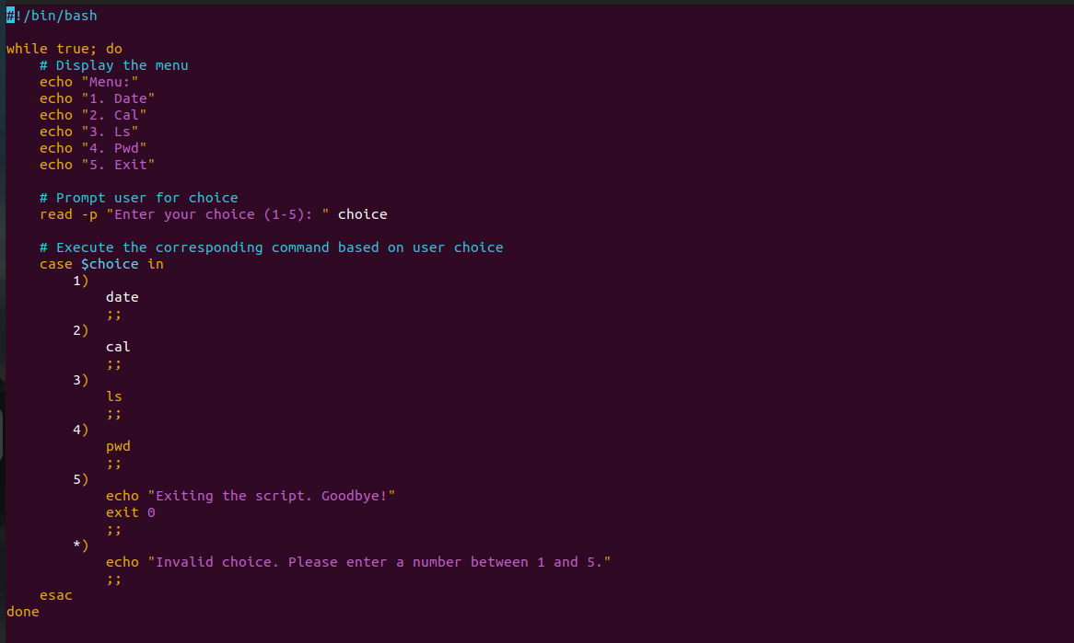

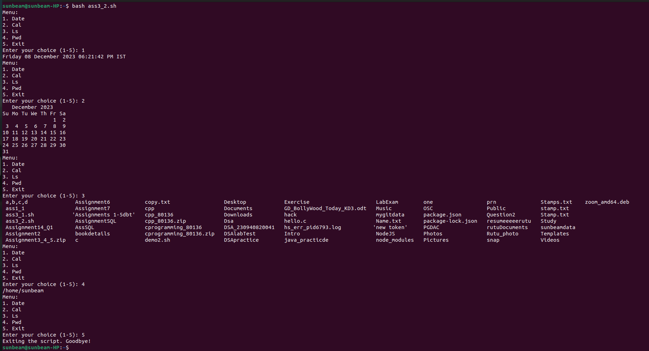

3)Write a shell script to accept the name from the user and check whether user entered name is file or directory. If name is file display its size and if it is directory display its contents.

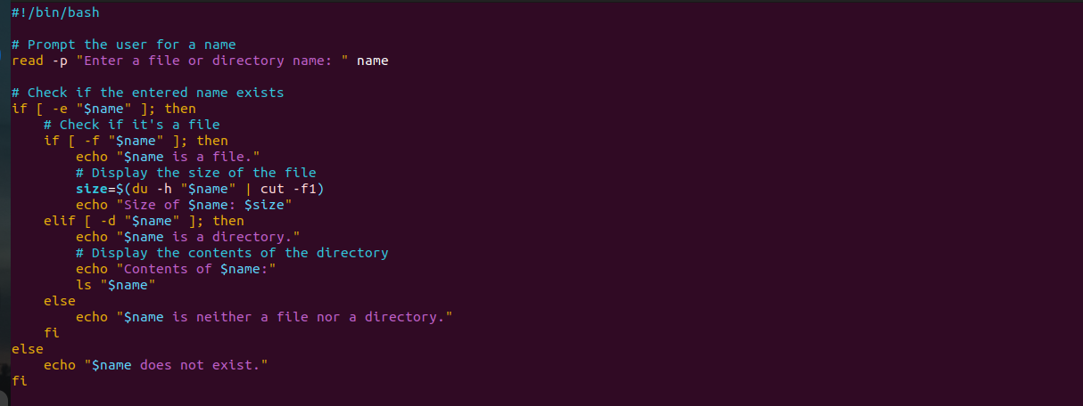

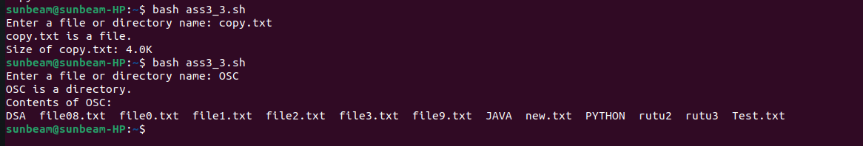

4)Write a shell script to determine whether a given number is prime or not.

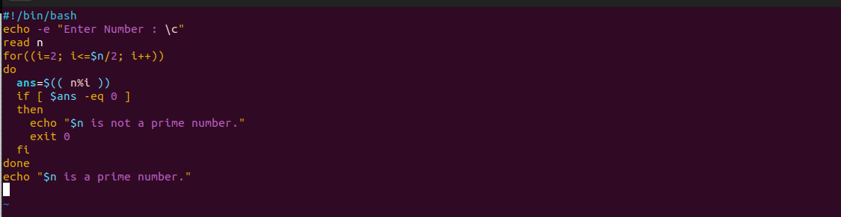
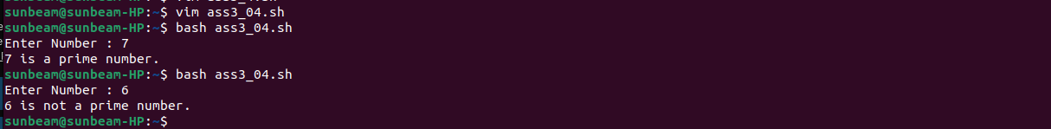

5)Write a Program to find the greatest of three numbers.

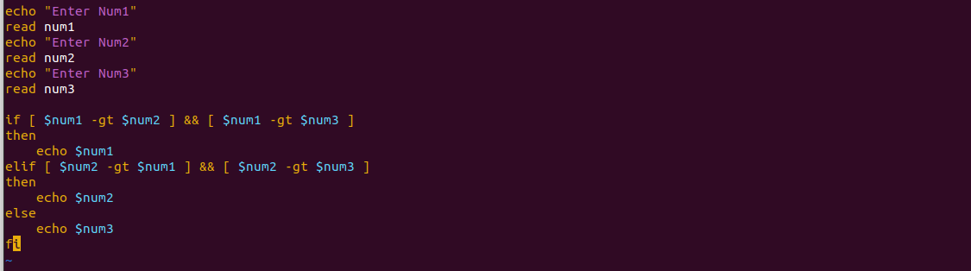
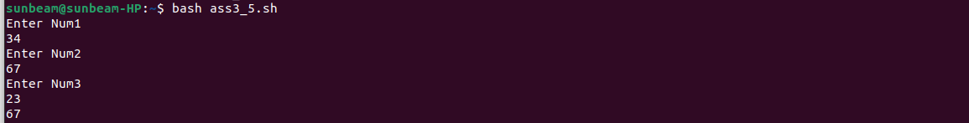

6)Write a Program to find whether a given year is a leap year or not.
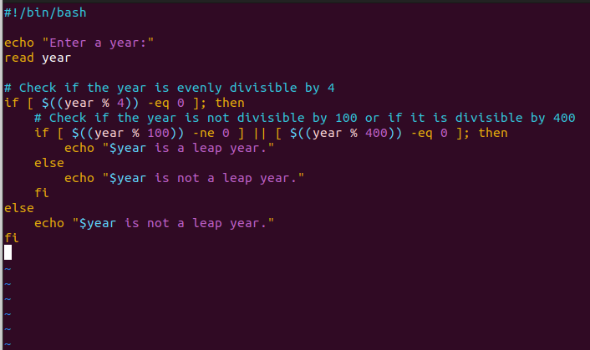

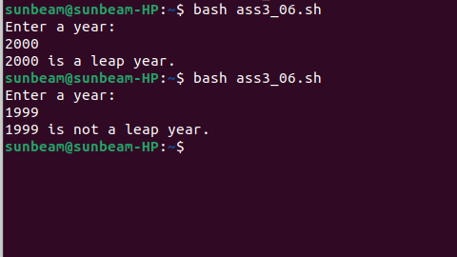

7)Write a Program to find whether a given number is positive or negative.
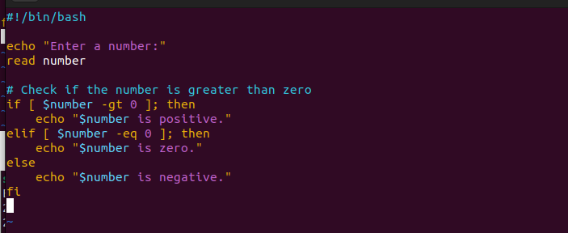

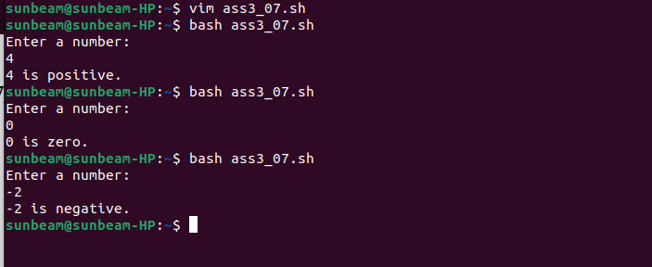

8)Write a program to print the table of a given number.
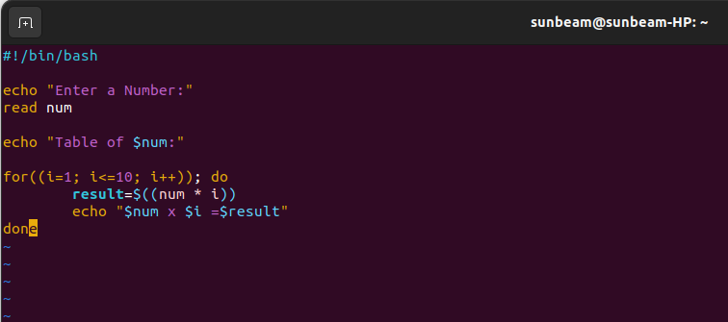

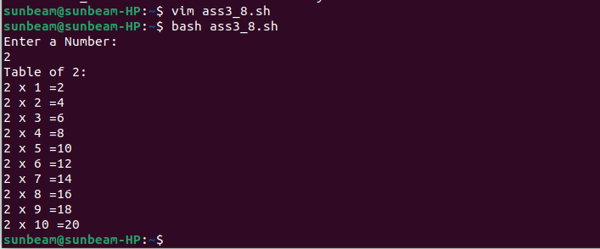

9)Write a program to find the factorial of given number.
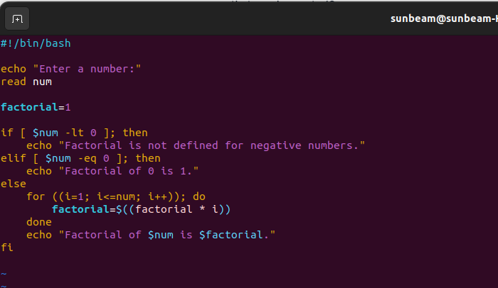

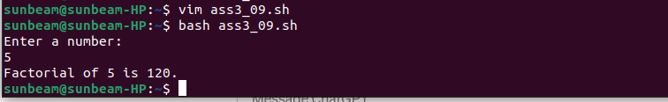

10)Write a program to find given number of terms in the Fibonacci series.

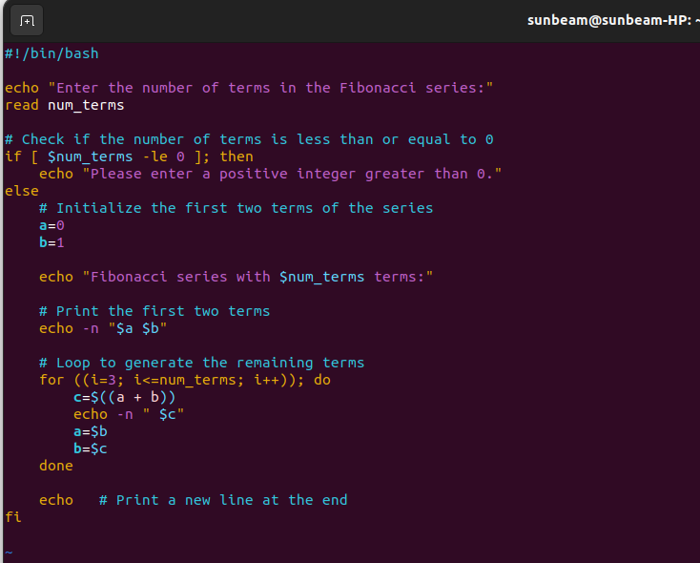

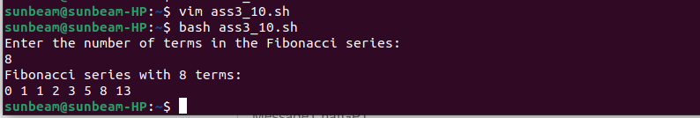

11)Write a program to calculate gross salary if the DA is 40%, HRA is 20% of basic salary.Accept basic salary form user and display gross salary (Result can be floating point value).

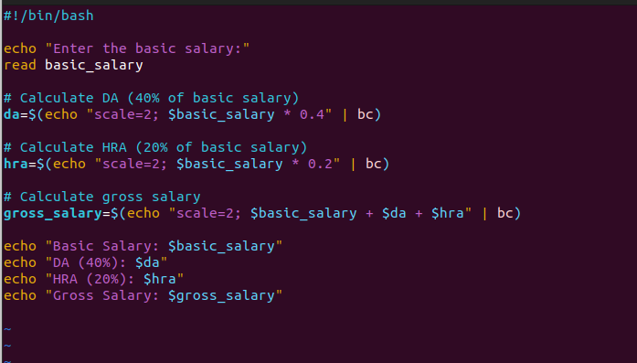

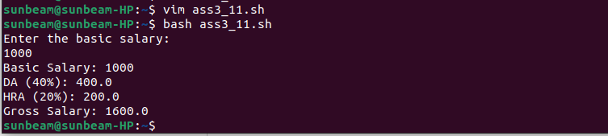

12)Write a shell script to accept a filename as argument and displays the last modification time if the file exists and a suitable message if it doesn’t exist.
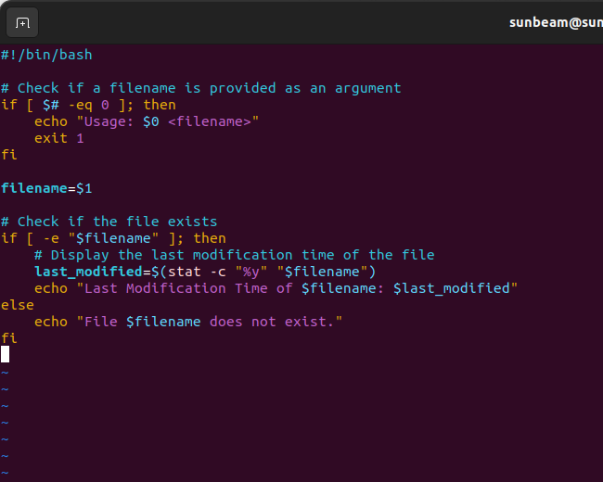

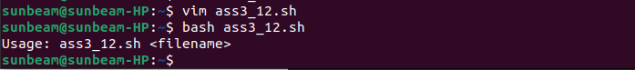

13)Write a shell script to display only hidden file of current directory.

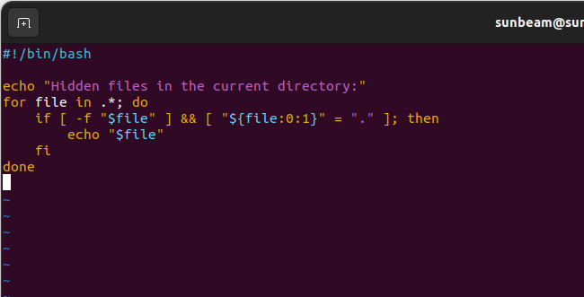

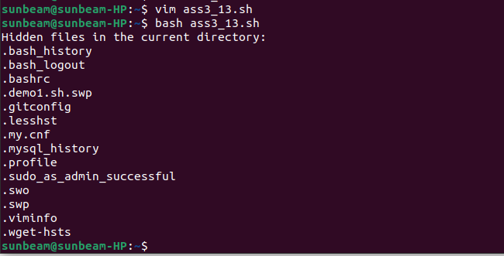

14)Write a shell script to display only executable files of current directory.

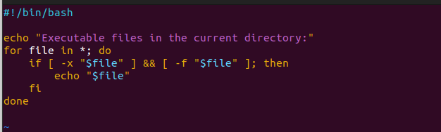

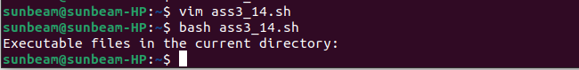

15)Accept the two file names from user and append the contents in reverse case of first file into second file.

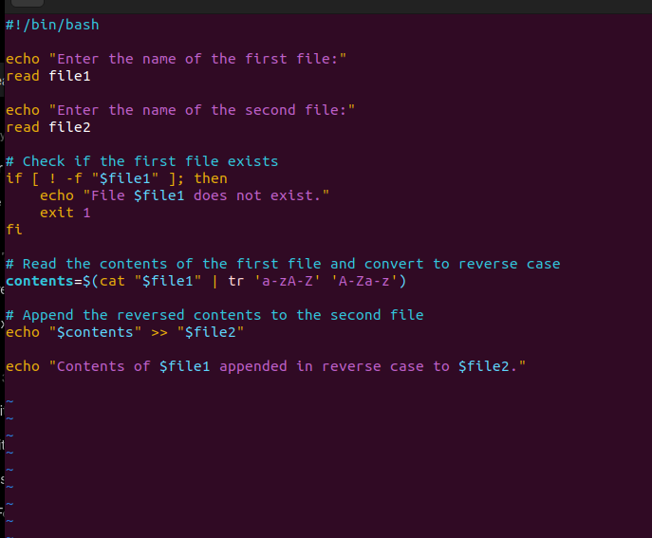

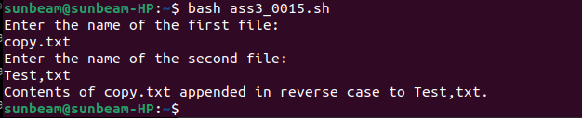

16)Write a shell script to display welcome message to the user along with contents of his home directory. Ensure that shell script will execute automatically when user login to the shell. (Make entry of your shell script into .bashrc file into your home directory).

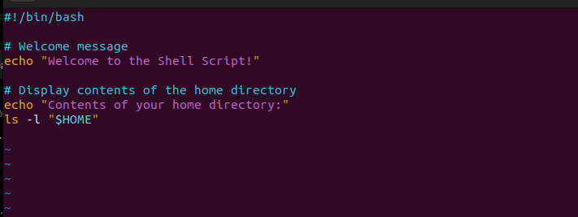

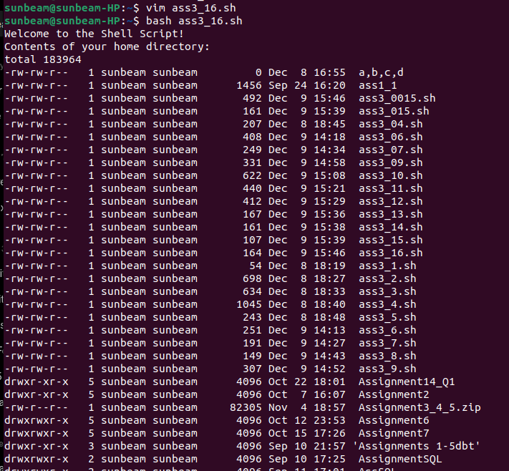

17)Print the following pattern.
*
* *
* * *
* * * *
* * * * *

