Name -Kunal Markam
Rollno - 80155
Group – KD4
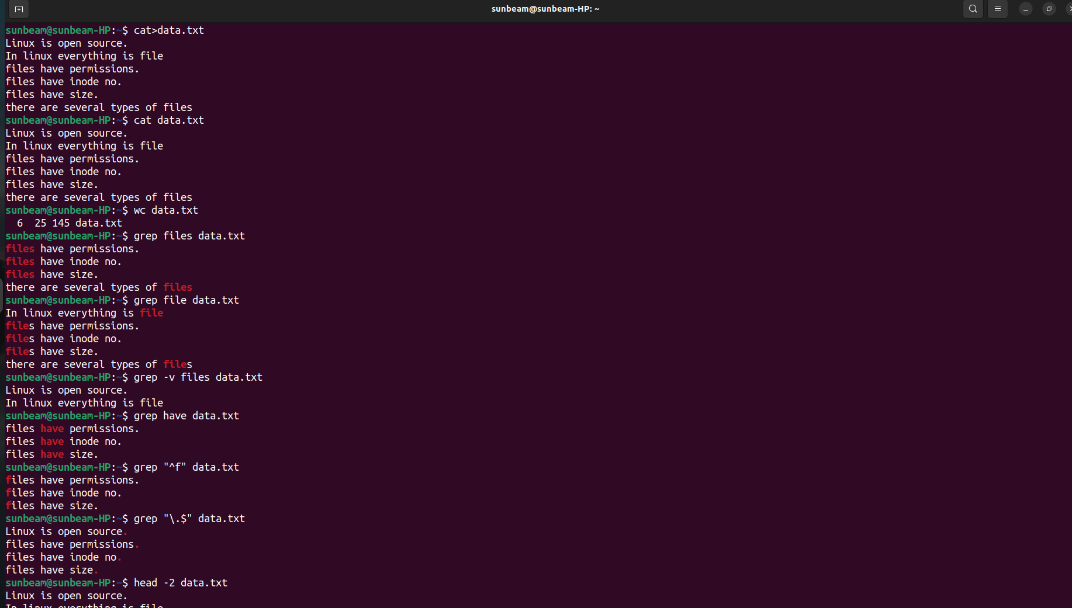
Assignment No.4
