Q.1)Install MongoDB database server

$ sudo apt-get install gnupg curl
$ curl -fsSL https://pgp.mongodb.com/server-7.0.asc | \sudo gpg -o /usr/share/keyrings/mongodb-server-7.0.gpg \--dearmor
------------------------------------------------------------------------------------------------------------------------
Q.2) Create a directory/folder to store MongoDB datafiles

$ echo "deb [ arch=amd64,arm64 signed-by=/usr/share/keyrings/mongodb-server-7.0.gpg ] https://repo.mongodb.org/apt/ubuntu jammy/mongodb-org/7.0 multiverse" | sudo tee /etc/apt/sources.list.d/mongodb-org-7.0.list
------------------------------------------------------------------------------------------------------------------------
Q.3) Set necessary path environment variable

title:'MySQL programming', authors:['Jack','Jill'], likes:200Answer:
$ echo "deb [ arch=amd64,arm64 signed-by=/usr/share/keyrings/mongodb-server-7.0.gpg ] https://repo.mongodb.org/apt/ubuntu jammy/mongodb-org/7.0 multiverse" | sudo tee /etc/apt/sources.list.d/mongodb-org-7.0.list
------------------------------------------------------------------------------------------------------------------------
Q.4) Startup MongoDB database

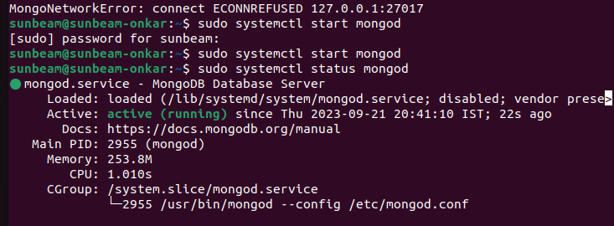
$ sudo systemctl start mongod
------------------------------------------------------------------------------------------------------------------------

Q.5) Connect to MongoDB database through the MongoDB shell command line interface

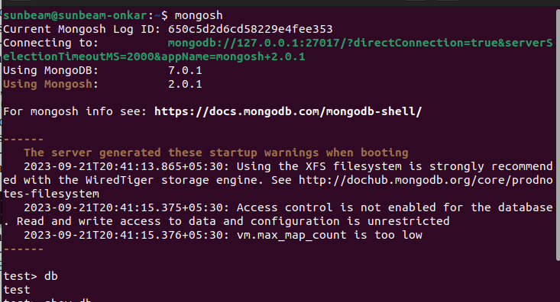
------------------------------------------------------------------------------------------------------------------------

Q.6) View list of available databases

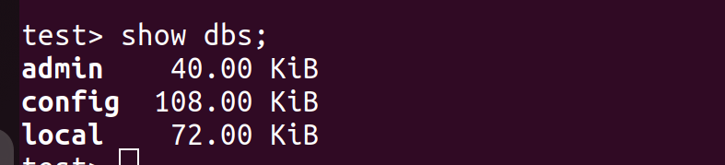
------------------------------------------------------------------------------------------------------------------------

Q.7) Create a new database named CDAC and connect to it

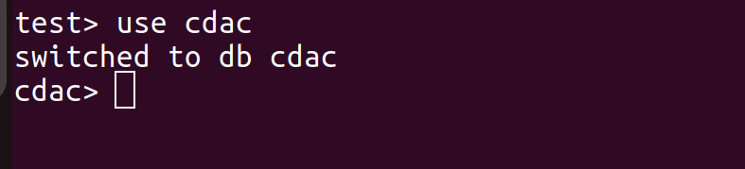
------------------------------------------------------------------------------------------------------------------------
Q.8) View list of available collections in CDAC database

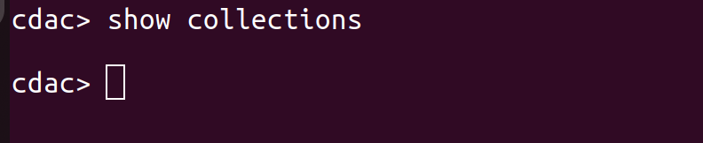
------------------------------------------------------------------------------------------------------------------------
Q.9) Create a new collection by the name of LIBRARY

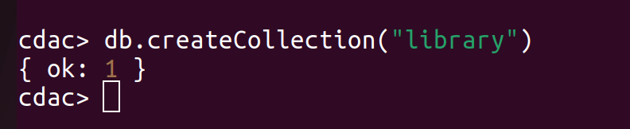
------------------------------------------------------------------------------------------------------------------------
Q.10) Insert the following document in the LIBRARY collection:-
title:'MongoDB programming', author:'Sameer', likes:100

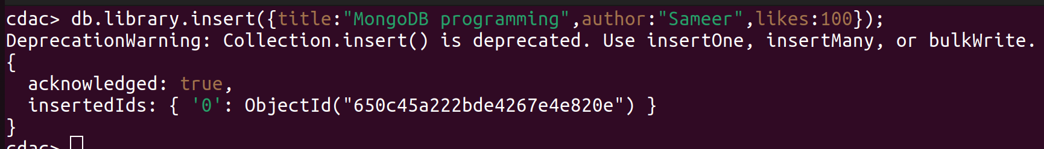
-----------------------------------------------------------------------------------------------------------------------
Q.11) View the recently inserted document and note the _id field

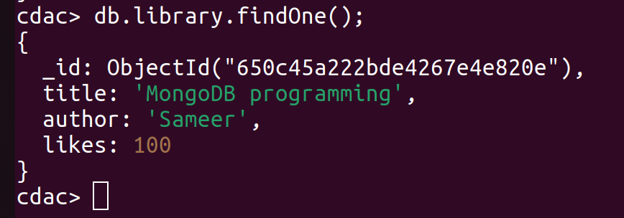
------------------------------------------------------------------------------------------------------------------------

Q.12) Insert another document in the LIBRARY collection as follows:-

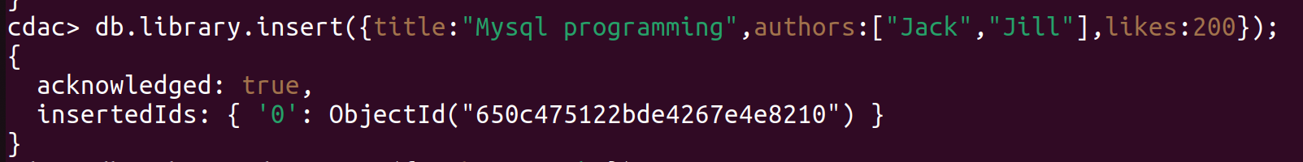
------------------------------------------------------------------------------------------------------------------------
Q.13) View the inserted documents

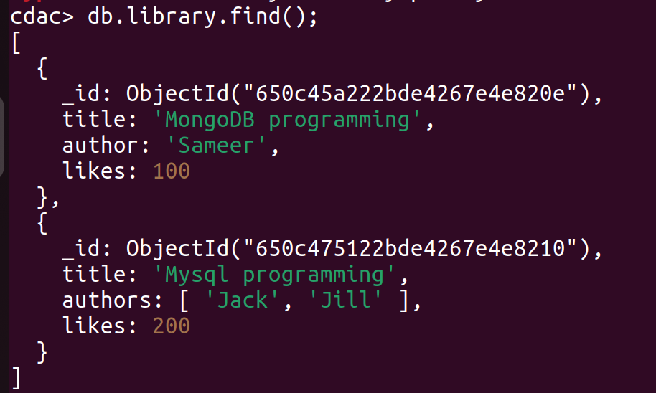
------------------------------------------------------------------------------------------------------------------------
Q.14) View only the first inserted document

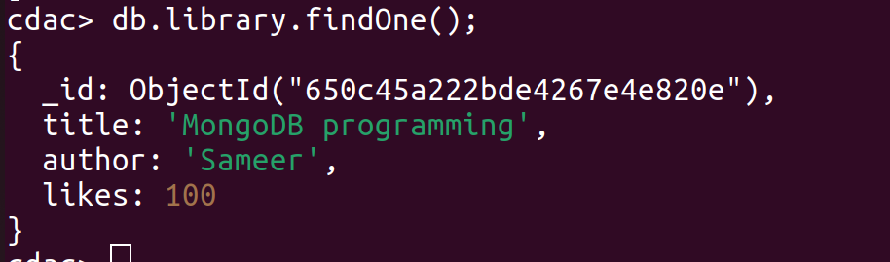
------------------------------------------------------------------------------------------------------------------------

Q.15) View the documents using the pretty() method

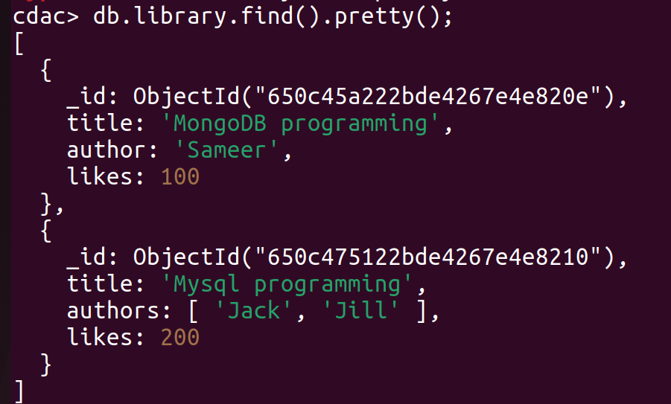
------------------------------------------------------------------------------------------------------------------------
Q.16) Update the document where author name = Sameer and change it to Sameer Dehadrai

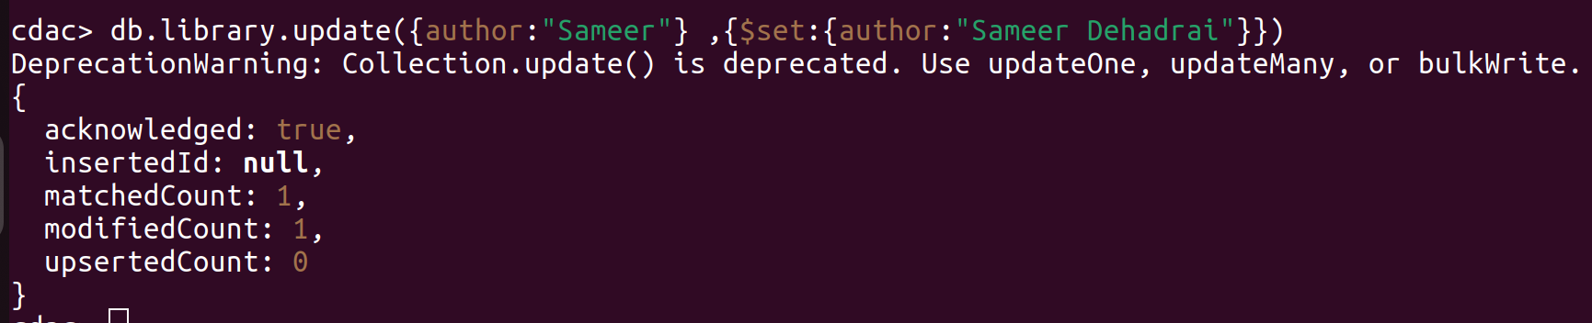
------------------------------------------------------------------------------------------------------------------------

Q.17) Delete all documents that have 100 likes

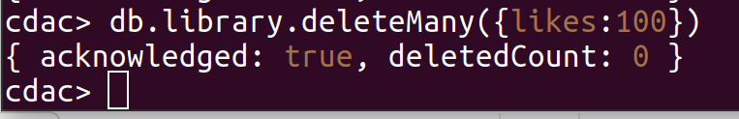
------------------------------------------------------------------------------------------------------------------------

Q.18) Drop the LIBRARY collection

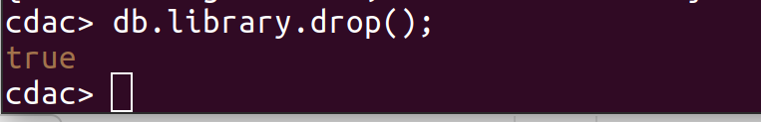
------------------------------------------------------------------------------------------------------------------------
Q.19) Drop the CDAC database

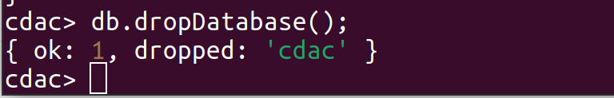
------------------------------------------------------------------------------------------------------------------------
Q.20) Exit from MongoDB shell

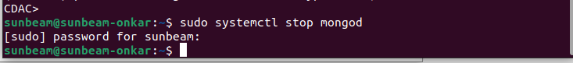
------------------------------------------------------------------------------------------------------------------------
Q.21) Stop MongoDB server

------------------------------------------------------------------------------------------------------------------------

