ASSIGNMENT NO – 7

SUMMARIZING DATA WITH AGGREGATE FUNCTIONS.

1) WRITE A QUERY THAT COUNTS ALL ORDERS FOR OCTOBER 3.
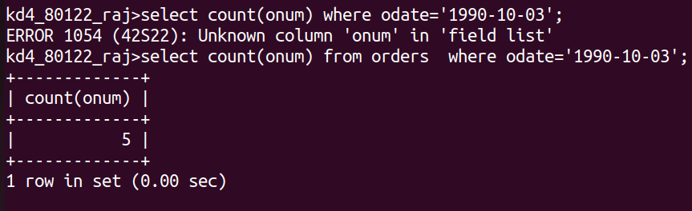
2) write a query that counts the number of different non-NULL city values in the cutomers table.
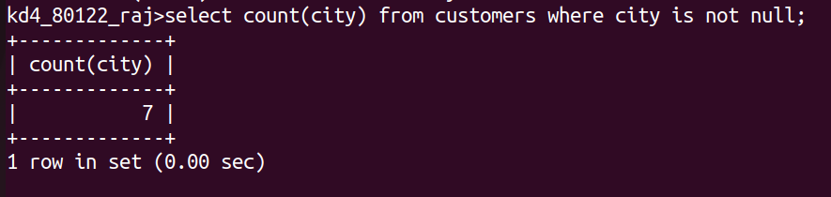
3)write a query that selects each customer’s smallest order.
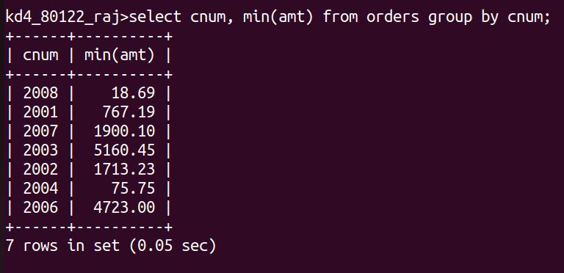
4) write a query that selects the first customer in alphabetical order, whose name begins with G.
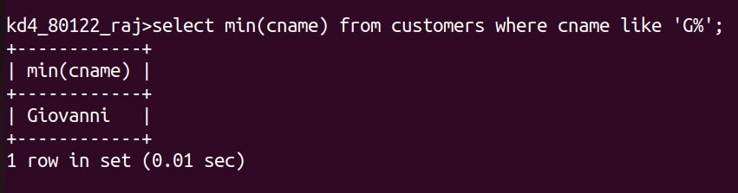
5) write a query that selects the highest rating in each city.
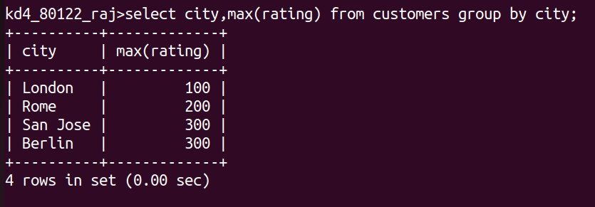
6) write a query that counts the number of salespeople registering orders for each day.( if a salespeople has more then one order on a givenday, he or she should be counted only once.).
