SQL ASSIGNMENT-5

RELATIONAL AND LOGICAl OPERATORS.

1) write a query that will give you all orders for more than Rs. 1000.
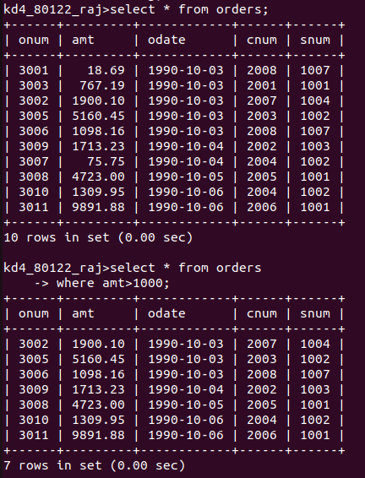

2) write a query that will give you the names and citites of all salespeople in london with a commission above 0.10

3) write a query on the customers table whose output will exclude all customers with a rating<=100, unless
they are located in Rome.
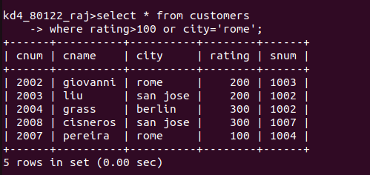

4) what will be the output from the following query?

Select * from orders
where (amt<1000 or not (odate=’1990-10-03’ and cnum>2003));

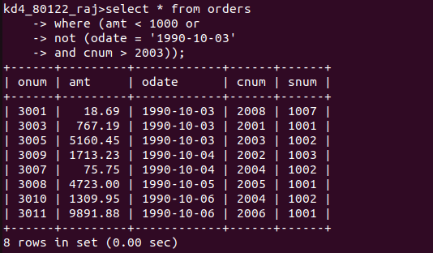
5)
select * from orders
where not ((odate=’1990-10-03’ or snum>1006) and amt>=1500);

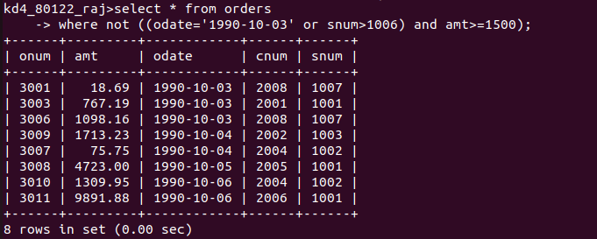

6)
what is a simpler way to write this query?
Select snum,sname,city,comm from salespeople where (comm>0.12 or comm<0.14);
