SQL ASSIGNMENT – 14

Entering,Deleting, and changing field values.

1) Write a command that puts the following values, in their given order, into the salespeople table: city-San Jose, name-Blanco, comm-NULL,snum -1100.

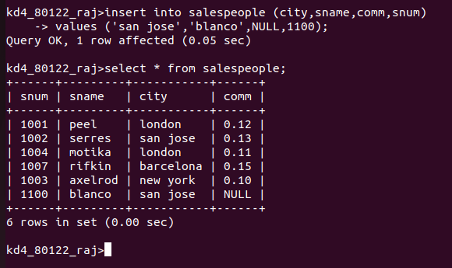

2)Write a command that removes all orders from customer Clemens from the Orders table.
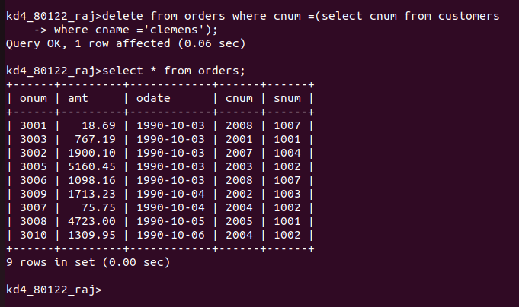
3) Write a command that increases the rating of all customers in Rome by 100.

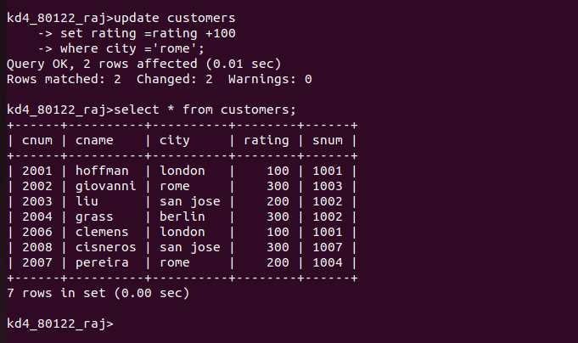

4) Salesperson Serres has left the company. Assign her customers to Motika.
