ASSIGNMENT NO-6

USING SPECIAL OPERATORS IN CONDITIONS

1) write two different queries that would produce all orders taken on october 34d or 4th, 1990.

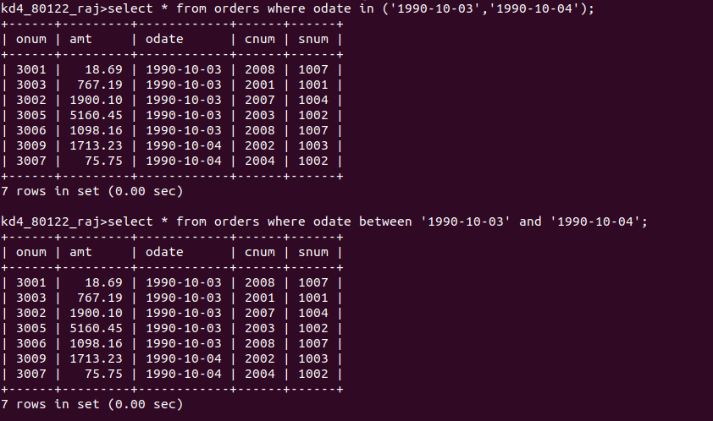
2) write a query that selects all the customers serviced by peel or motika.(HINT: the snum field relates the two tables to one another).

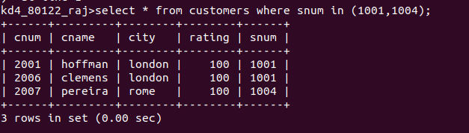

3) write aquery that will produce all the customers whose name begin with a letter from ‘A’ to ‘G’.
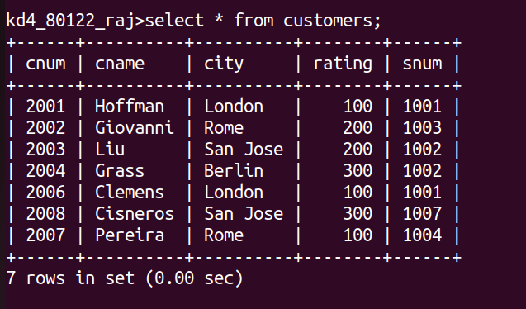

4) write a query that selects all the customers whose names begin with the letter ‘C’.

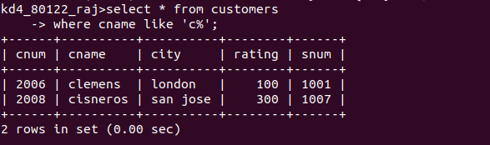

5) write a query that selects all orders except those with zeroes or nulls in the amt field.

