SQL ASSIGNMENT – 10

JOINING A TABLE TO ITSELF

1) Write a query that produces all the pairs of salespeople who are living in the city. Exclude combinationsof salespeople with themselves as well as duplicate rows with the order reversed.
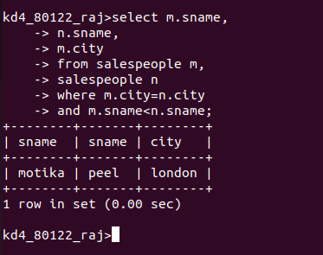

2) Write a query that produces the names and cities of all customers with the same rating as hoffman.
