SQL ASSIGNMNET-4

RETRIVING INFORMATION FROM TABLES.

1) Write a select command that produces the order number, amount, and date for all rows in the orders table.
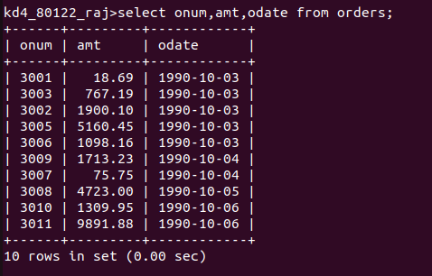

2) write a query that produces all rows from the customers table for which the salespeople number is 1001.
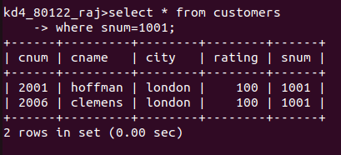

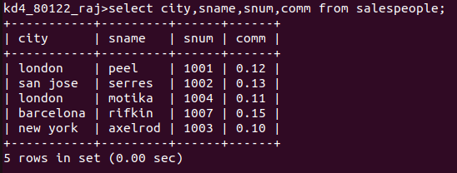
3) write a query that displays the salespeople table with the colums in the following order: city,sname,snum,comm.
4)write a select command that produces the rating followed by the name of each customer in san jose.
