Assignment- 9
1) Write a query that lists each order number followed by the name of the customer who made the order.
Ans:-

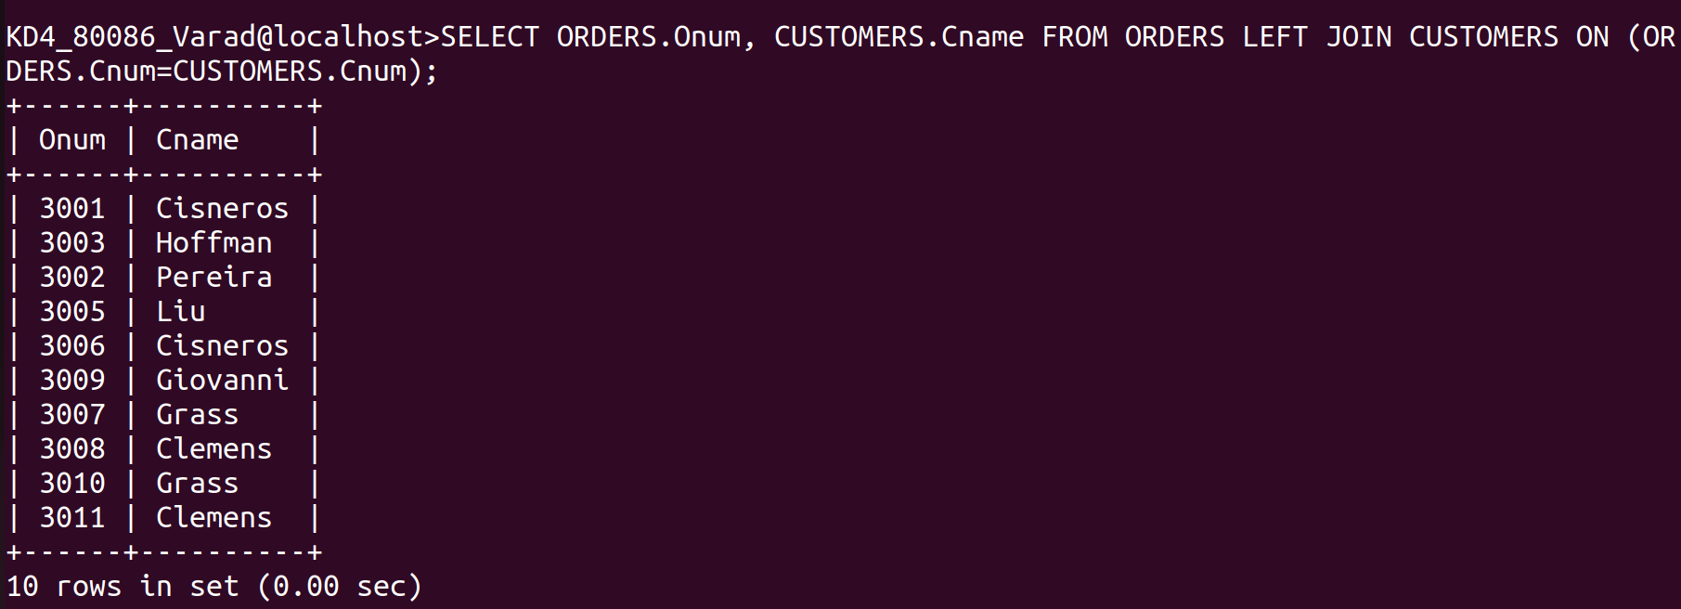
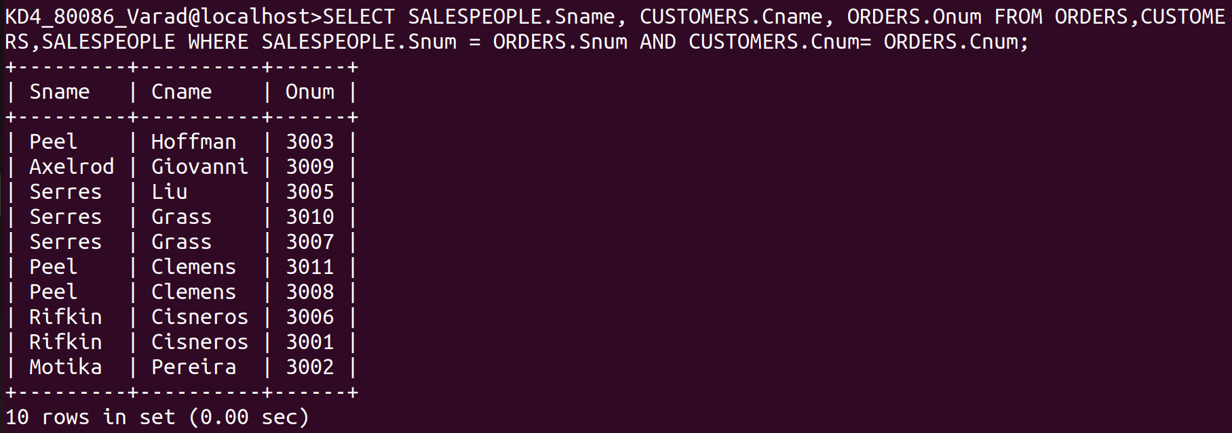
SELECT ORDERS.Onum, CUSTOMERS.Cname FROM ORDERS LEFT JOIN CUSTOMERS ON (ORDERS.Cnum=CUSTOMERS.Cnum);
2)Write a query that gives the names of both the salesperson and the customers for each order along with the order number.
Ans:-
SELECT SALESPEOPLE.Sname, CUSTOMERS.Cname, ORDERS.Onum FROM ORDERS,CUSTOMERS,SALESPEOPLE WHERE SALESPEOPLE.Snum = ORDERS.Snum AND CUSTOMERS.Cnum= ORDERS.Cnum;
3) Write a query that produces all customers serviced by salespeople with a commission above 12%. Output the customers’s name , the salesperson’s name, and the salesperson’s rate of commission.

Ans:-
SELECT CUSTOMERS.Cname, SALESPEOPLE.Sname, SALESPEOPLE.Comm FROM CUSTOMERS,SALESPEOPLE WHERE CUSTOMERS.Snum=SALESPEOPLE.Snum AND SALESPEOPLE.Comm>.12;

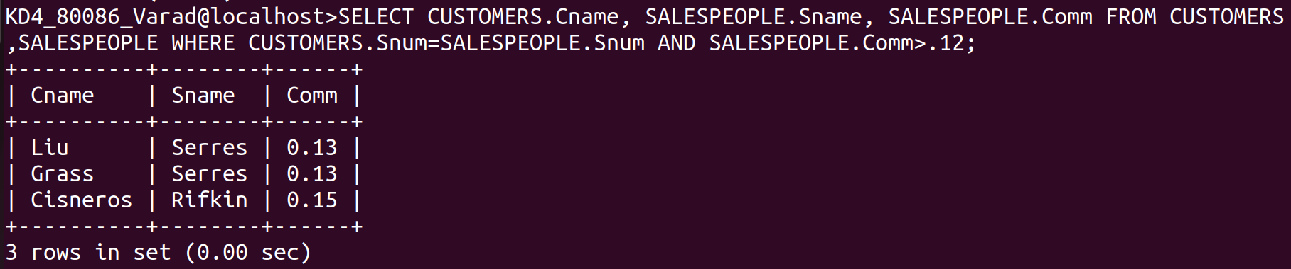
4) Write a query that calculates the amount of the salesperson’s commission on each order by a customer with a rating above 100.
Ans:-
SELECT Onum, Amt*Comm Commission FROM ORDERS,CUSTOMERS, SALESPEOP
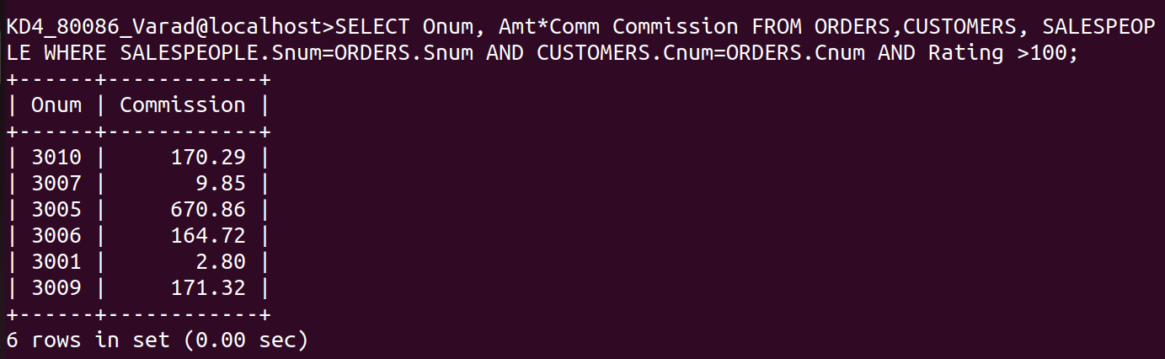
LE WHERE SALESPEOPLE.Snum=ORDERS.Snum AND CUSTOMERS.Cnum=ORDERS.Cnum AND Rating >100;

