1. Install MongoDB database server
2. Create a directory/folder to store MongoDB datafiles
3. Set necessary path environment variable
4. Startup MongoDB database
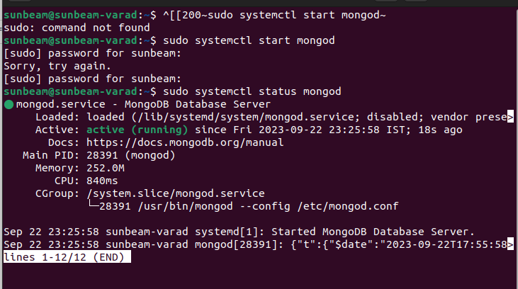
5. Connect to MongoDB database through the MongoDB shell command line interface
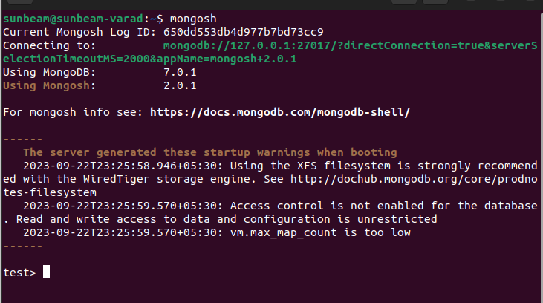
6. View list of available databases
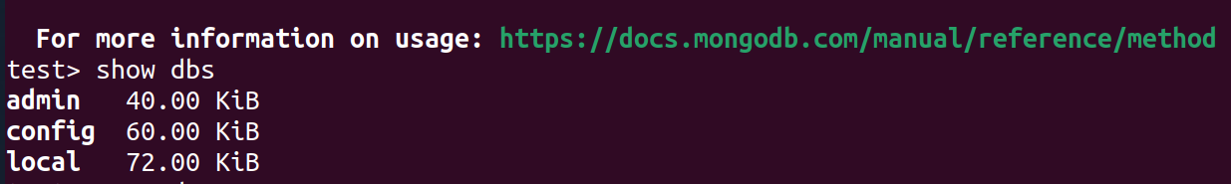
7. Create a new database named CDAC and connect to it
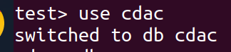

8. View list of available collections in CDAC database
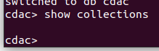

9. Create a new collection by the name of LIBRARY
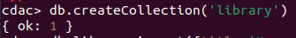

10. Insert the following document in the LIBRARY collection:-
title:'MongoDB programming', author:'Sameer', likes:100

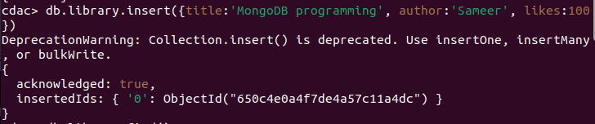

11. View the recently inserted document and note the _id field
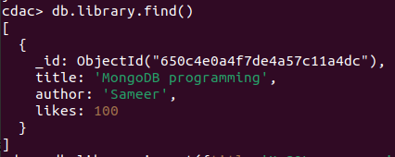

12. Insert another document in the LIBRARY collection as follows:-
title:'MySQL programming', authors:['Jack','Jill'], likes:200

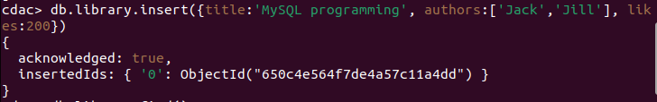
13. View the inserted documents
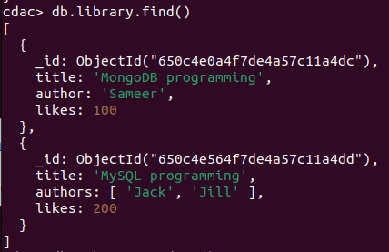

14. View only the first inserted document
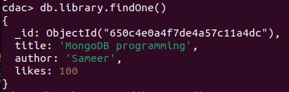

15. View the documents using the pretty() method
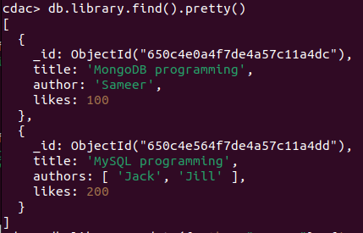

16. Update the document where author name = Sameer and change it to Sameer Dehadrai
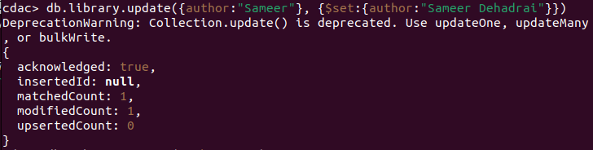

17. Delete all documents that have 100 likes
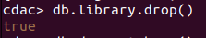

18. Drop the LIBRARY collection
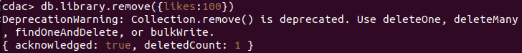
19. Drop the CDAC database
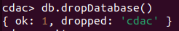

20. Exit from MongoDB shell
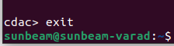

21. Stop MongoDB server

