ASSIGNMENT – 15
Q1. Assume there is a table called Multicust, with all of the same column definitions as Salespeople. Write a command that inserts all salespeople with more than one customer into this table.
Ans.
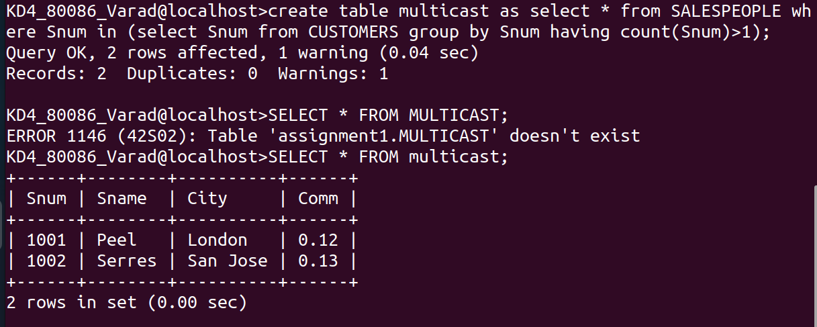
Q2. Write a command that deletes all customers with no current orders.
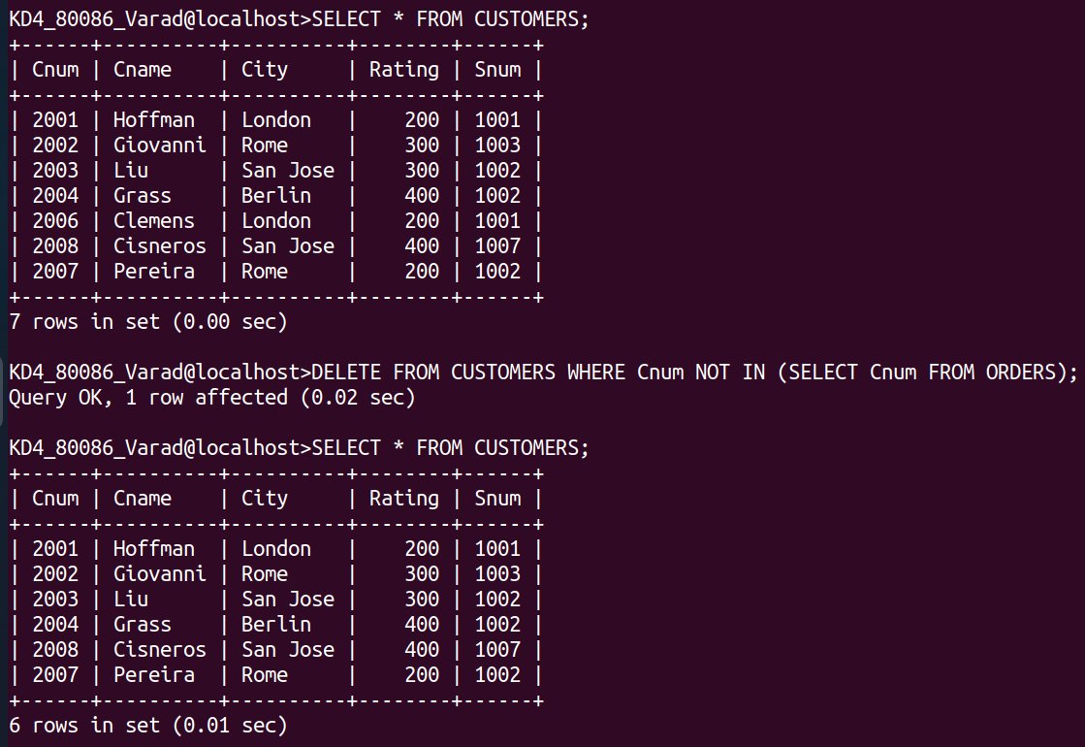
Ans.

Q3. Write a command that increases by twenty percent the commissions of all salespeople with total orders above Rs. 3000.
Ans.
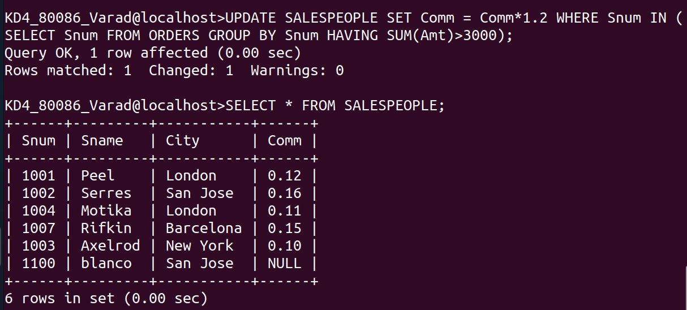
UPDATE SALESPEOPLE SET Comm = Comm*1.2 WHERE Snum IN (SELECT Snum FROM ORDERS GROUP BY Snum HAVING SUM(Amt)>3000);

