ASSIGNMENT – 11

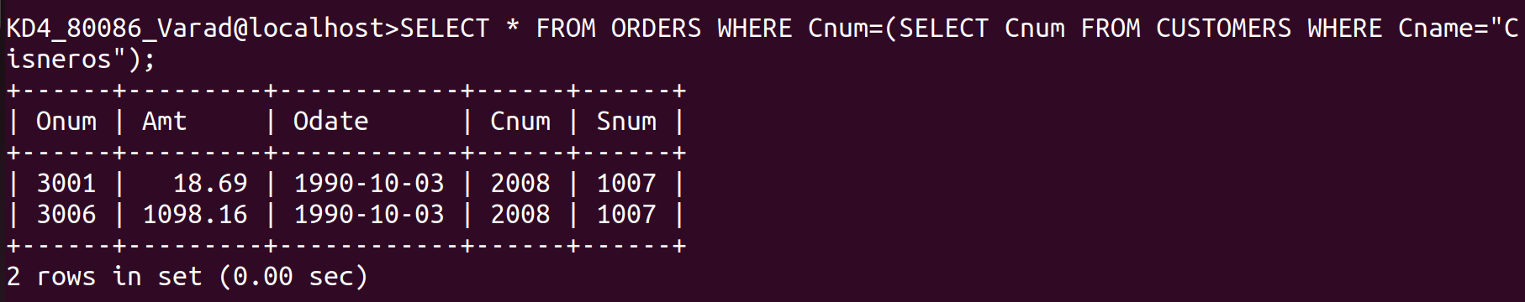
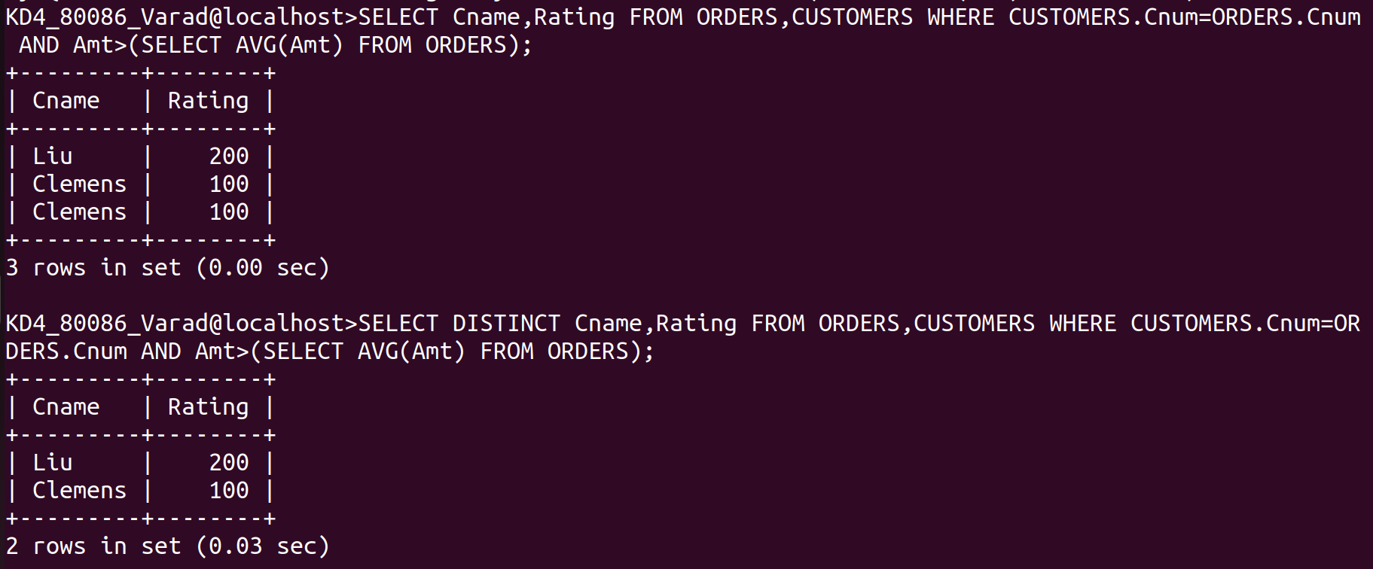
1) Write a query that uses a subquery to obtain all orders for the customer named Cisneros. Assume you do not know his customer number(Cnum)
Ans:-
SELECT * FROM ORDERS WHERE Cnum=(SELECT Cnum FROM CUSTOMERS WHERE Cname="Cisneros");
2) Write a query that produces the names and ratings of all customers who have above-average orders.
Ans:-
Query 1:- SELECT Cname,Rating FROM ORDERS,CUSTOMERS WHERE CUSTOMERS.Cnum=ORDERS.Cnum AND Amt>(SELECT AVG(Amt) FROM ORDERS);
Query 2:- SELECT DISTINCT Cname,Rating FROM ORDERS,CUSTOMERS WHERE CUSTOMERS.Cnum=ORDERS.Cnum AND Amt>(SELECT AVG(Amt) FROM ORDERS);
3) Write a query that selects the total amount in orders for each salesperson for whom this total is greater than the amount of the largest order in the table.
Ans:-
SELECT Snum,SUM(Amt) FROM ORDERS GROUP BY Snum HAVING SUM(Amt)>(SELECT MAX
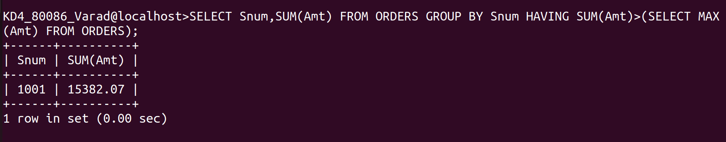
(Amt) FROM ORDERS);

