ASSIGNMENT-5

1. Write a query that will give you all orders for more than Rs. 1,000.
Ans- SELECT * FROM ORDERS WHERE Amt >1000;

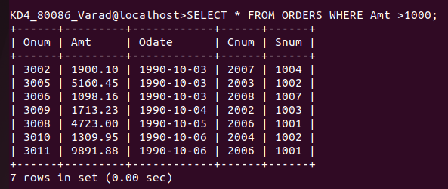
2. Write a query that will give you the names and the cities all salespeople in London with a commission above .10
Ans- SELECT Sname, City FROM SALESPEOPLE WHERE City= 'London' AND Comm >.10;
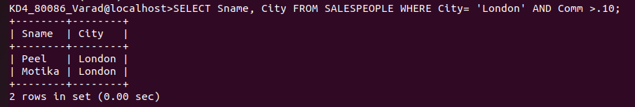
3. Write a query on the customers table whose output will exclude all customers with a rating <=100, unless they are located in Rome.
Ans- SELECT * FROM CUSTOMERS WHERE City = 'Rome' OR Rating>100;

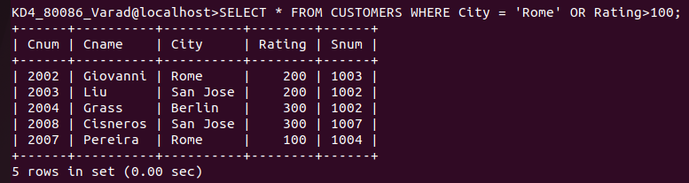
4. What will be the ouyput from the following query?

Select * from orders where (amt < 1000 or not (odate =’1990-10-03’ and cnum>2003));
Ans:-

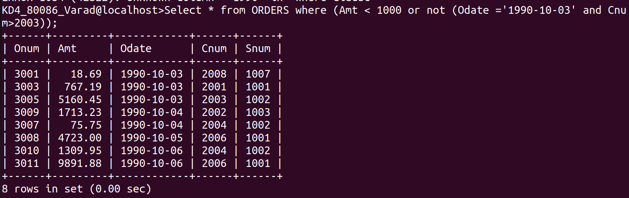
5. What will be the output of the following query?

Select * from orders where not ((odate = ‘1990-10-03’ or snum>1006) and amt>=1500);
Ans:-

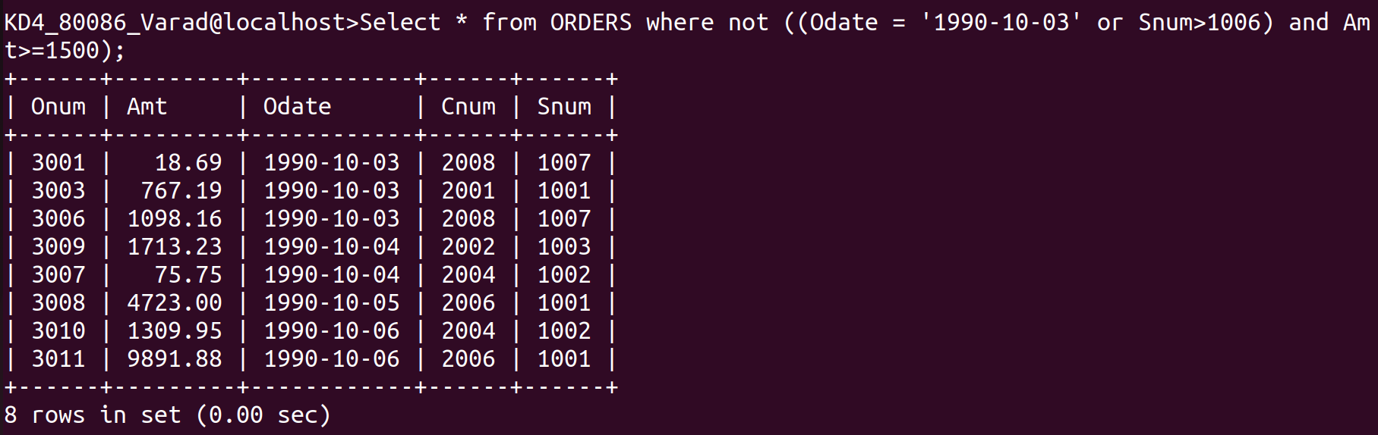

6. What is the simplest way to write this query ? Select snum,sname,city,comm from the salespeople where (comm >.12 or comm <.14);
Ans -
SELECT * FROM SALESPEOPLE;

