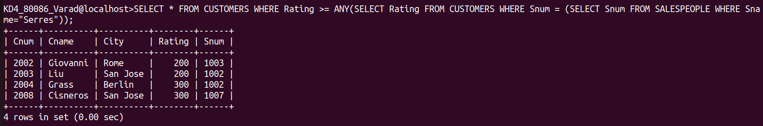
Assignment- 12
1)
Ans:-
SELECT * FROM CUSTOMERS WHERE Rating >= ANY(SELECT Rating FROM CUSTOMERS WHERE Snum = (SELECT Snum FROM SALESPEOPLE WHERE Sname="Serres"));
2)
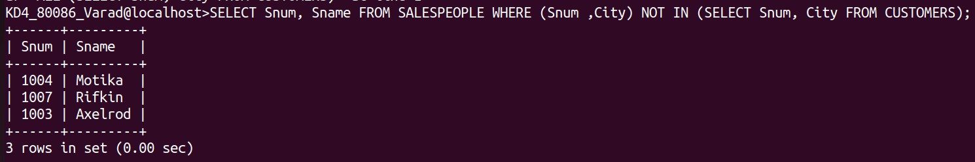
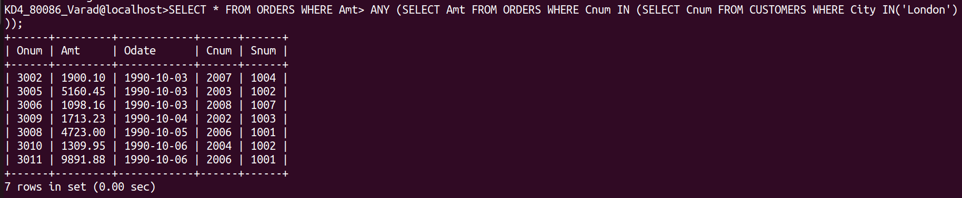
Ans:-
SELECT Snum, Sname FROM SALESPEOPLE WHERE (Snum ,City) NOT IN (SELECT Snum, City FROM CUSTOMERS);
3) Write a query that selects all orders for amounts greater than any for the customers in London.
Ans:-
SELECT * FROM ORDERS WHERE Amt> ANY (SELECT Amt FROM ORDERS WHERE Cnum IN (SELECT Cnum FROM CUSTOMERS WHERE City IN('London')));

4) Write the above query using MIN or MAX.

