1. Write two different queries that would produce all orders taken on October 3rd or 4th, 1990.
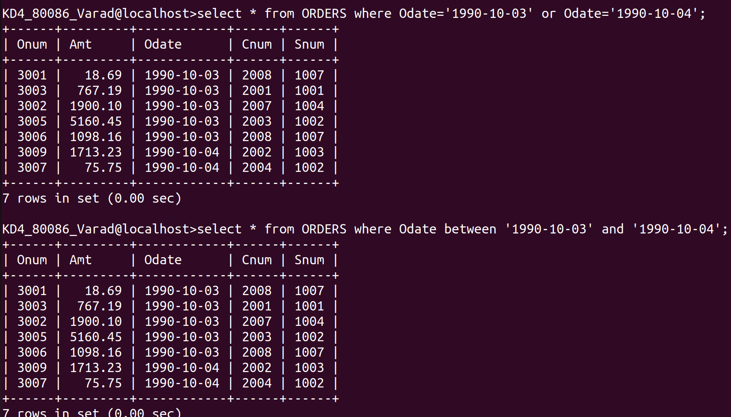
ans:-
select * from ORDERS where Odate='1990-10-03' or Odate='1990-10-04';
select * from ORDERS where Odate between '1990-10-03' and '1990-10-04';
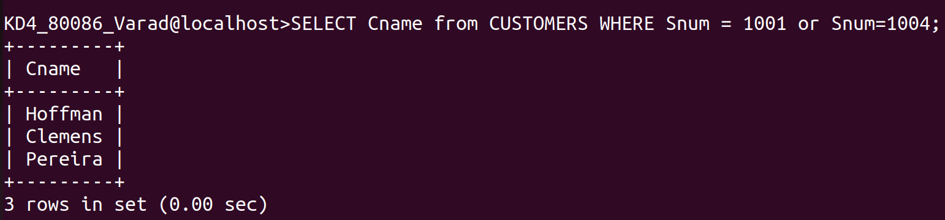
2. Write a query that selects all of the customers serviced by peel or motika.
ans:-
SELECT Cname from CUSTOMERS WHERE Snum = 1001 or Snum=1004;
3. Write a query that will produce all the customers whose names begin with a letter from ‘A’ to ‘G’.
Ans:-
QUERY1:- SELECT Cname FROM CUSTOMERS WHERE Cname BETWEEN 'A%' and 'G%';
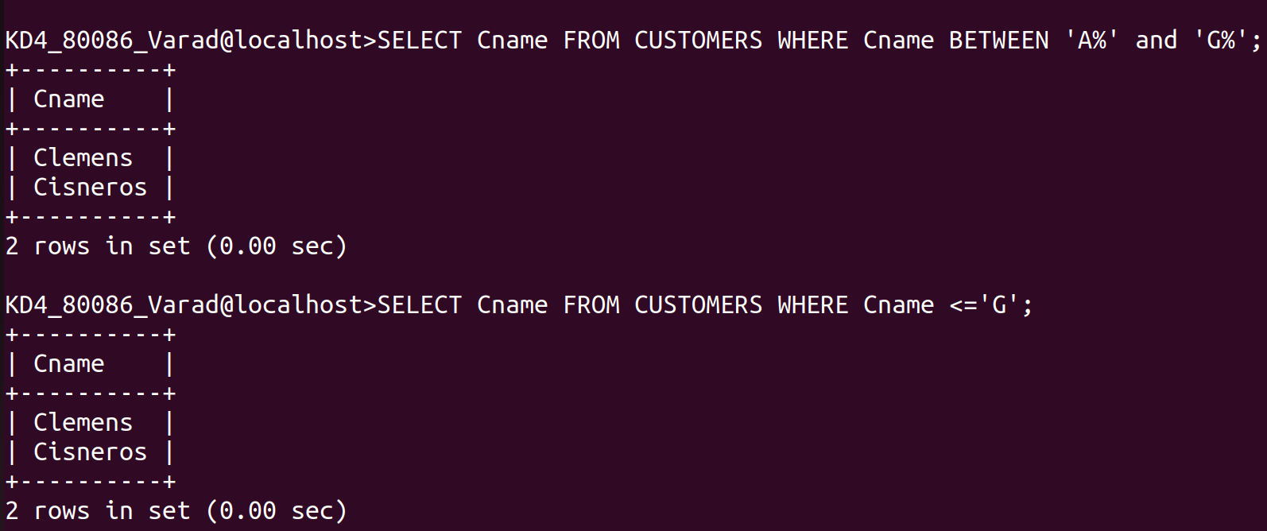
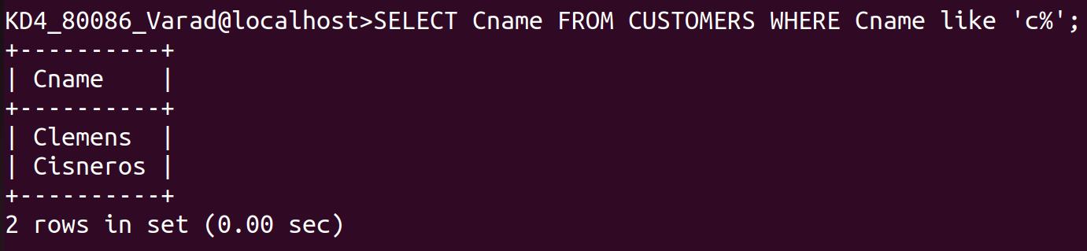
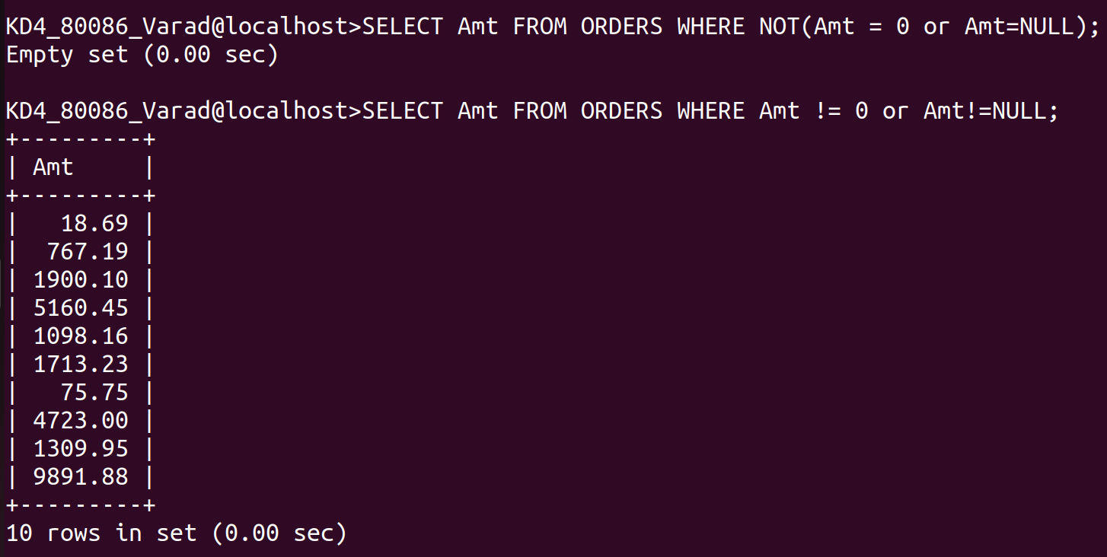
QUERY2:- SELECT Cname FROM CUSTOMERS WHERE Cname <='G';
4. Write a query that selects all customers whose names begin with the letter ‘C’.
ans:-
SELECT Cname FROM CUSTOMERS WHERE Cname like 'c%';
5. Write a query that selects all orders except those with zeroes or NULLs in the Amt field.
Ans:
QUERY1:- SELECT Amt FROM ORDERS WHERE NOT(Amt = 0 or Amt=NULL);
QUERY2:- SELECT Amt FROM ORDERS WHERE Amt != 0 or Amt!=NULL;

