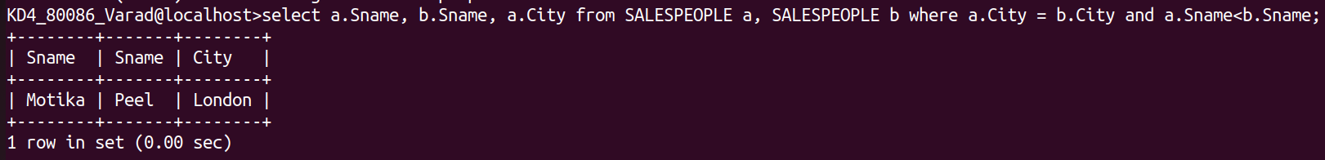
Assignment-10
1)Write a query that produces all pairs of salespeople who are living in the same city. Exclude combinations of salespeople with themselves as well as duplicate rows with the order reversed.
Ans:
select a.Sname, b.Sname, a.City from SALESPEOPLE a, SALESPEOPLE b where a.City = b.City and a.Sname<b.Sname;
2)Write a query that produces the names and cities of all customers with the same rating as hoffman.
Ans:-
SELECT X.Cname, X.City FROM CUSTOMERS X,CUSTOMERS Y WHERE X.Rating=Y.Rating AND Y.Cname="Hoffman";

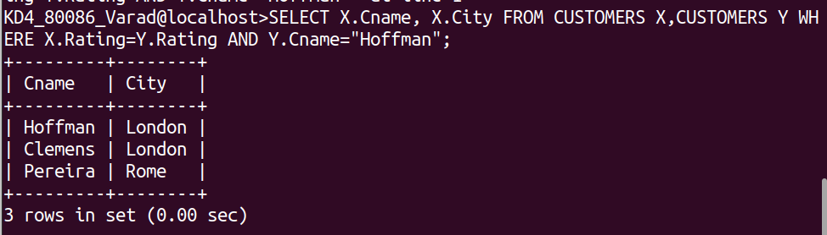

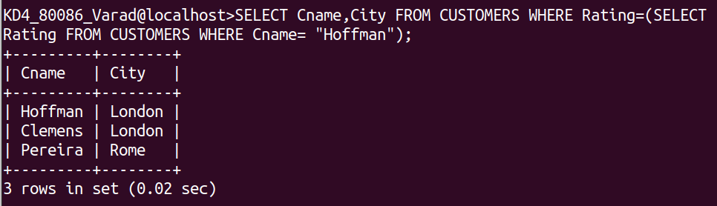
SELECT Cname,City FROM CUSTOMERS WHERE Rating=(SELECT Rating FROM CUSTOMERS WHERE Cname= "Hoffman");

