ASSIGNMENT – 4

1) Write a select command that produces the order number, amount and date for all rows in the Orders table.

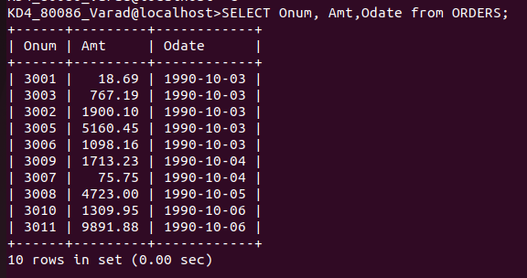
ANS:- SELECT Onum, Amt,Odate from ORDERS;
2)Write a query that produces all rows from the Customers table for which the salesperson’s number is 1001.
ANS:- SELECT * FROM CUSTOMERS WHERE Snum=1001;
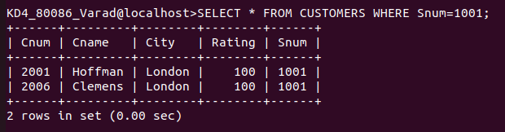

3) Write a query that displays the Salespeople table with the columns in the following order: city, sname, snum, comm.

ANS:- SELECT City,Sname,Snum,Comm from SALESPEOPLE;

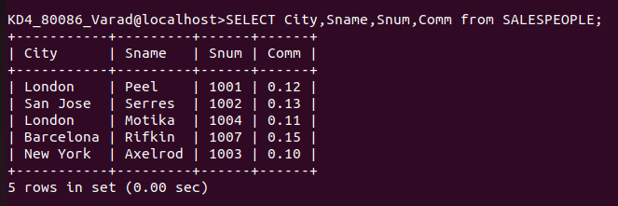
4) Write a select command that produces the rating followed by the name of each customer in San Jose.

Ans:- SELECT Rating, Cname from CUSTOMERS WHERE City= 'San Jose';

