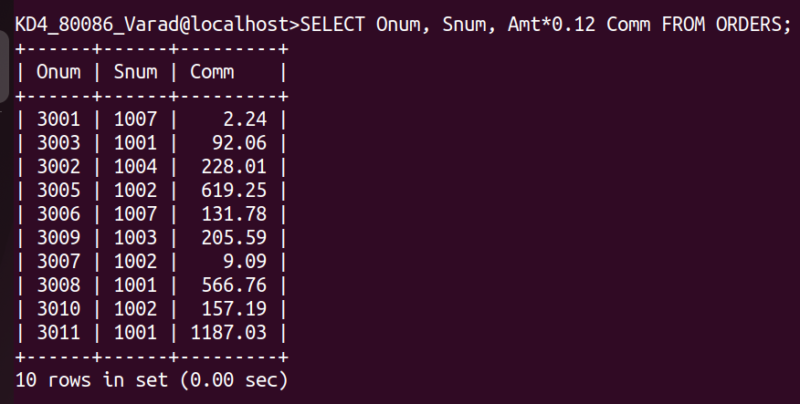
ASSIGNMENT-8
1) Assume each salesperson has a 12% commission. Write a query on the orders table that will produce the order number , salesperson number, & amount of salesperson’s commission for that order.
ANS:-
SELECT Onum, Snum, Amt*0.12 Comm FROM ORDERS;
2) Write a query on the Customers table that will find the highest rating in each city. Put the output in this form:
For the city (city), the highest rating is :(rating).
ANS:-
SELECT CONCAT(City,' is the highest rating is: ',MAX(Rating)) AS HIGHEST_RATING FROM CUSTOMERS GROUP BY City;
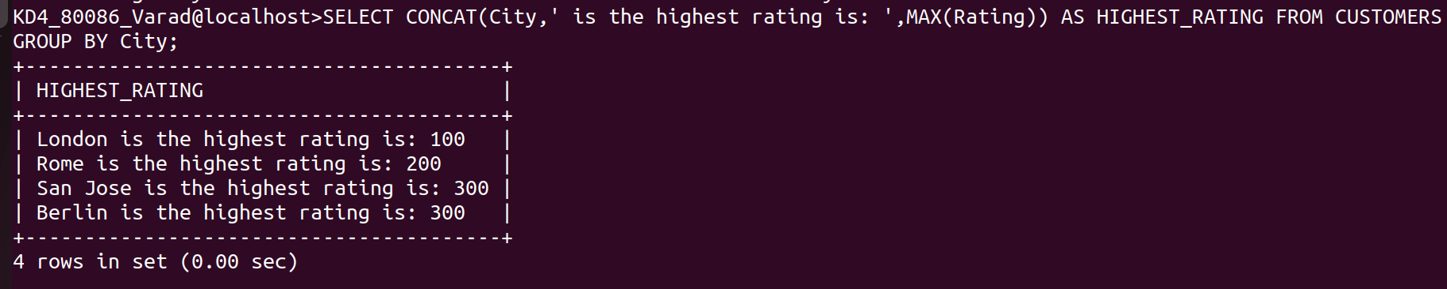
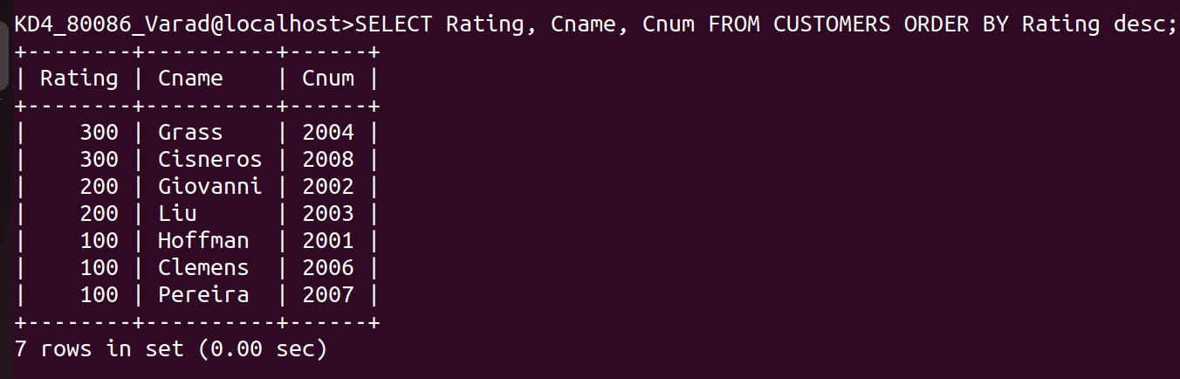
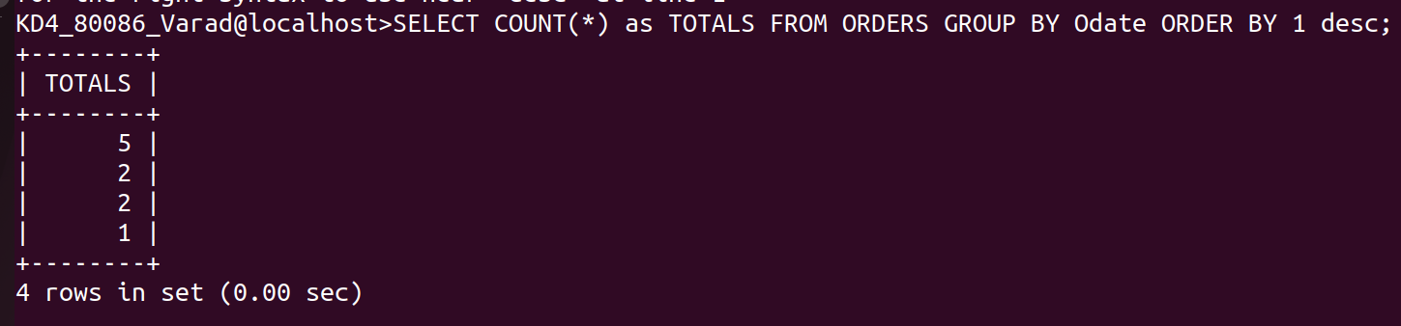
3) Write a query that lists customers in descending order of rating. Output the rating field first, followed by the customers’s name and number.
Ans:-
SELECT Rating, Cname, Cnum FROM CUSTOMERS ORDER BY Rating desc;
4) Write a query that totals the orders for each day and places the results in descending order.
Ans:-
SELECT COUNT(*) as TOTALS FROM ORDERS GROUP BY Odate ORDER BY 1 desc;

