ASSIGNMENT-7
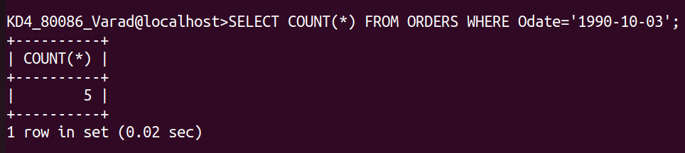
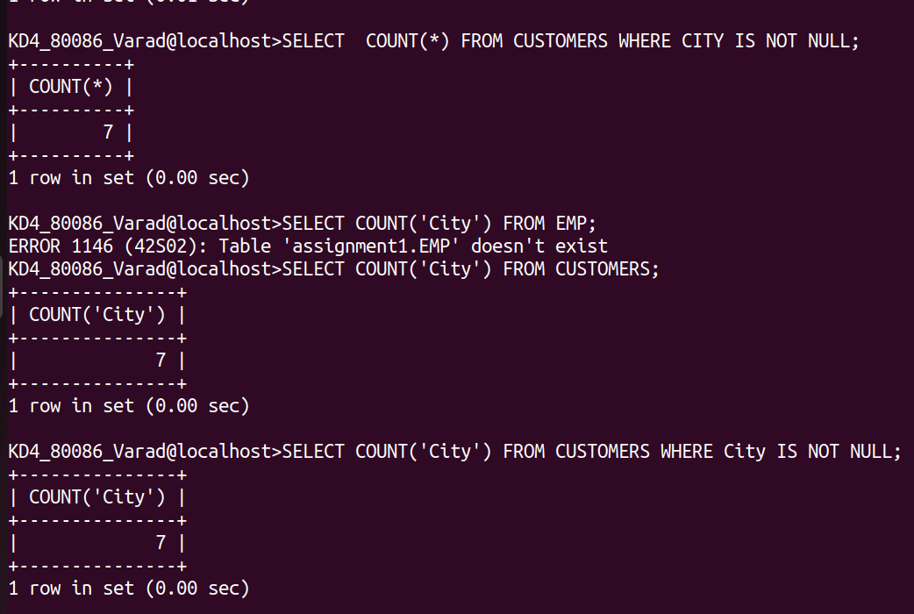
- Write a query that counts all orders for October 3.
ans:-
SELECT COUNT(*) FROM ORDERS WHERE Odate='1990-10-03';
2) Write a query that counts the number of different non-NULL city values in the customer table.
Ans:-
SELECT COUNT(*) FROM CUSTOMERS WHERE CITY IS NOT NULL;
SELECT COUNT('City') FROM CUSTOMERS WHERE City IS NOT NULL;
3) Write a Query that selects each customer’s smallest order.
Ans:
SELECT Cnum, min(Amt) FROM ORDERS GROUP BY CNUM;
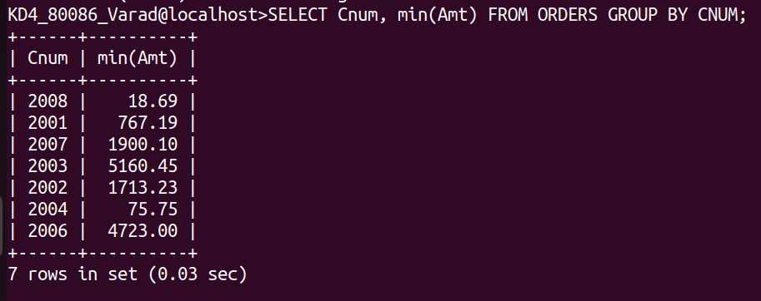
4) Write a query that selects the first customers in alphabetical order, whose name begins with G.
Ans:
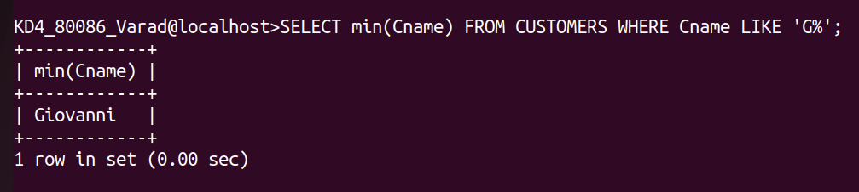
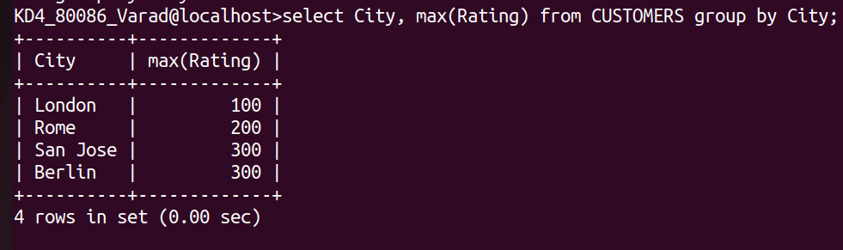
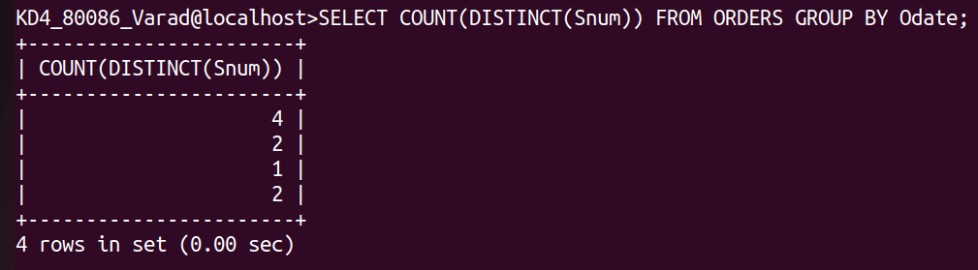
SELECT min(Cname) FROM CUSTOMERS WHERE Cname LIKE 'G%';
5) write a query that selects the highest rating in each city.
Ans:
select City, max(Rating) from CUSTOMERS group by City;
6) Write a query that counts the number of salespeople registering orders for each day.(if a salesperson has more than one order on a givenday, he or she should be counted only once.
Ans:
SELECT COUNT(DISTINCT(Snum)) FROM ORDERS GROUP BY Odate;

