SQL Assignment -1

Creating sample tables and inserting values.
Create the following tables with the given structures and insert sample data as specified:

A) SALESPEOPLE
ans: create table SALESPEOPLE
(Snum int(4),
Sname varchar(10),
City varchar(10),
Comm float(3,2));

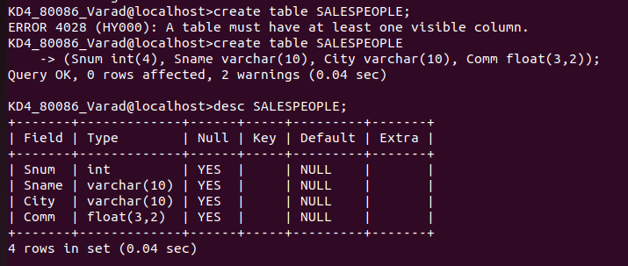

B) CUSTOMERS
ans: create table CUSTOMERS
(Cnum int(4),
Cname varchar(10),
City varchar(10),
Rating int(4),
Snum int(4));

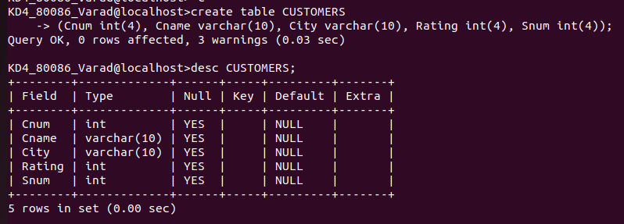
C) ORDERS:
ans: create table ORDERS
(Onum int(4),
Amt float(7,2),
Odate date,
Cnum int(4),
Snum int(4));

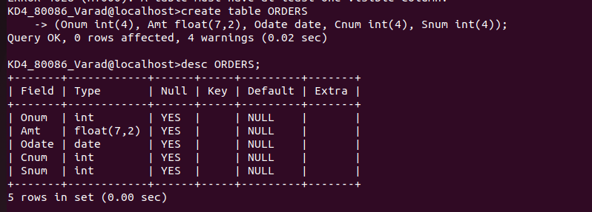

DATA INSERTING:

INSERT INTO SALESPEOPLE (Snum, Sname, City, Comm) VALUES
(1001, 'Peel','London',.12),(1002,'Serres','San Jose',.13), (1004,'Motika','London',.11),(1007,'Rifkin','Barcelona',.15), (1003, 'Axelrod','New York',.10);
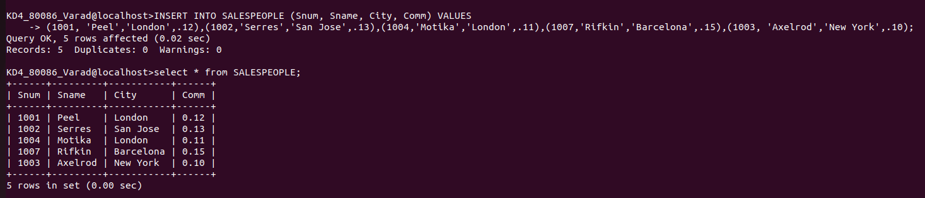
INSERT INTO CUSTOMERS(CNUM, CNAME, CITY, RATING, SNUM) VALUES
(2001, 'Hoffman','London',100,1001),(2002,'Giovanni','Rome',200,1003),
(2003,'Liu','San Jose',200,1002),
(2004,'Grass','Berlin',300,1002),
(2006,'Clemens','London',100, 1001),
(2008,'Cisneros','San Jose',300,1007),(2007,'Pereira','Rome',100,1004);

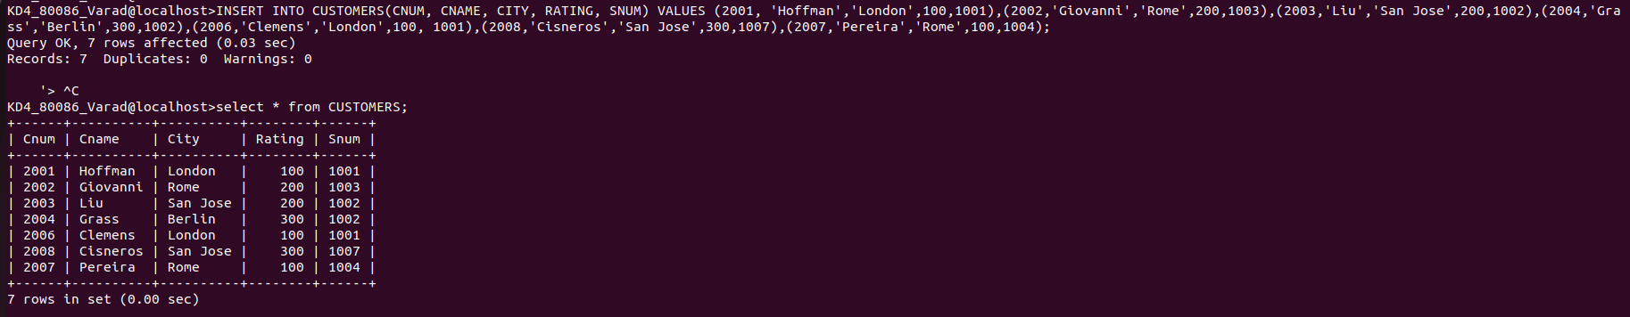
INSERT INTO ORDERS VALUES
(3001,18.69,'1990-10-03',2008, 1007),
(3003,767.19,'1990-10-03',2001,1001),
(3002, 1900.10,'1990-10-03',2007,1004),
(3005,5160.45,'1990-10-03',2003,1002),
(3006,1098.16,'1990-10-03',2008,1007),
(3009,1713.23,'1990-10-04',2002,1003),
(3007,75.75,'1990-10-04',2004,1002),
(3008,4723.00,'1990-10-05',2006,1001),
(3010,1309.95,'1990-10-06',2004,1002),
(3011,9891.88,'1990-10-06',2006,1001);
