Assignment No.3
Name:- Abhijeet Koturwar
Roll No. 80094
Group- KD4

1)ls(Display hidden files):-



2)rename(Rename all *.txt files to *.htm):-

3)ln -s(Create symbolic link (shortcut) for a file):-
4)ln(Create hard link for a file):-

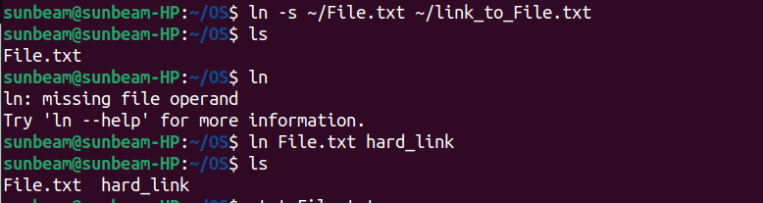

5)stat(Display time stamp of the file):-



6)touch(Change the time stamp of the file):-
7)touch(Create empty file):-

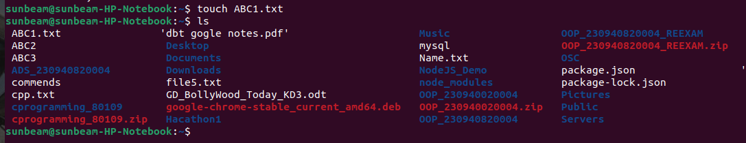

8)tail(Print all lines in a file from fifth line onwards):-

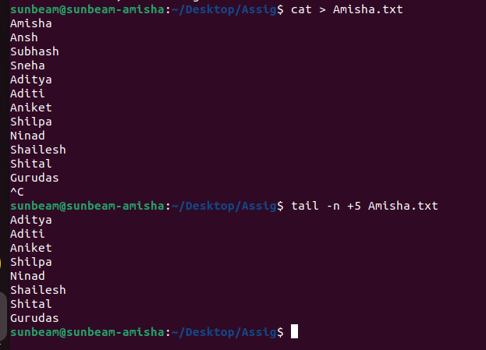

9)init 0, poweroff(Shutdown (Only for super-user)):-

-->sudo init 0

10)init 6, reboot(Reboot (Only for super-user)):-

-->sudo init 6

11)whoami(Find current user):-

12)tty(Find current terminal):-

13)who am i(Find current user and terminal):-


14)users(Find all users logged into the system):-

15)who(Find all users logged in and terminals in use):-

16)grep, egrep, fgrep(Find a given word/pattern from the file):-

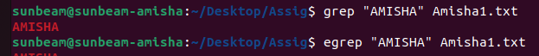

17)chmod(Make a file as read-only):-

18)chmod(Make a file as write, read and execute):-

19)wc (using redirection)(Take input from the file, count words and store output to other file):-

20)who | wc (using pipe)(Count words in output of “who” command):-

21)head, tail (using pipe)(Print lines 5 to 10 from the given file):-

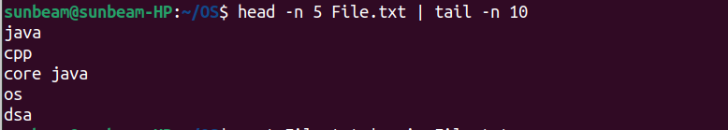

22)sort , uniq (using pipe)(Print the uniq values from the unsorted file):-
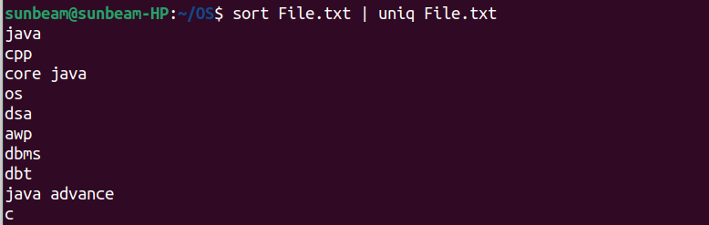

26)ls, grep (using pipe)(Display only hidden files in a directory):-

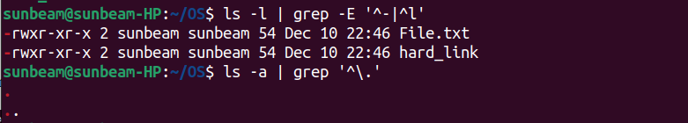

27)tr(Convert file contents into uppercase , also learn "-s" option of this command):-

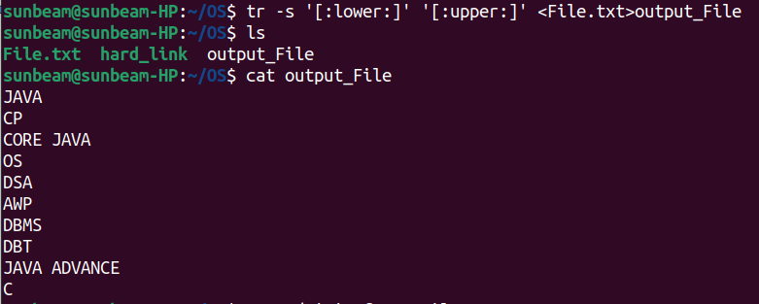

28)cut(Split the file contents using delimiter and print required fields):-
