Using special operaors in conditions

1) Write two different queries that woud produce all orders taken on october 3rd or 4th,1990.
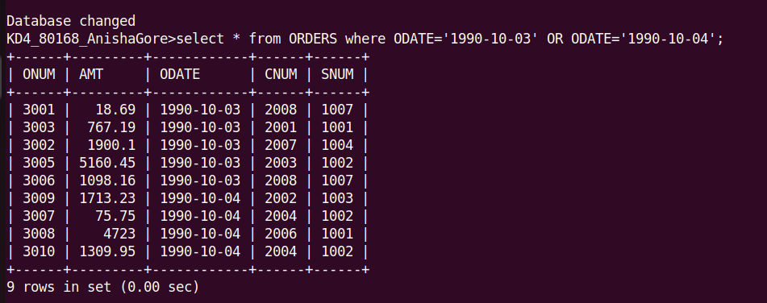

2) Write a query that selects all the customers serviced by peel or Motika

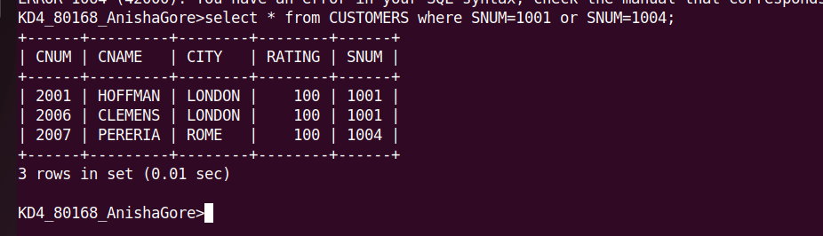

3)Write a query taht will produce all the customers whose names begin with a letter from ‘A’ to ‘G’

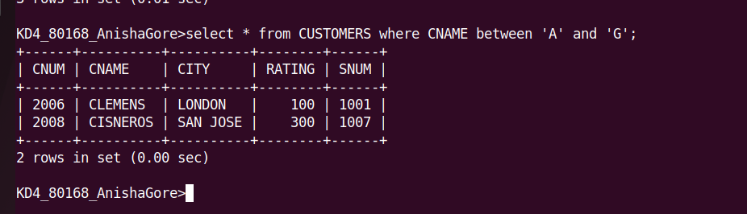

4)Write a query that selects all customers whose names begin with the letter ‘C’

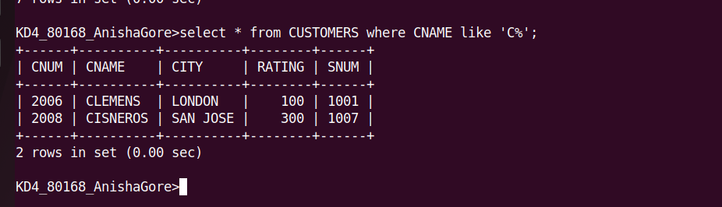

5)Write a query that selects all orders excepts those with zeroes or NULLs in the amt field.

