Assignment 12

1)Write a query that selects all customers whose ratings are equal to or greater than any of ‘serres’
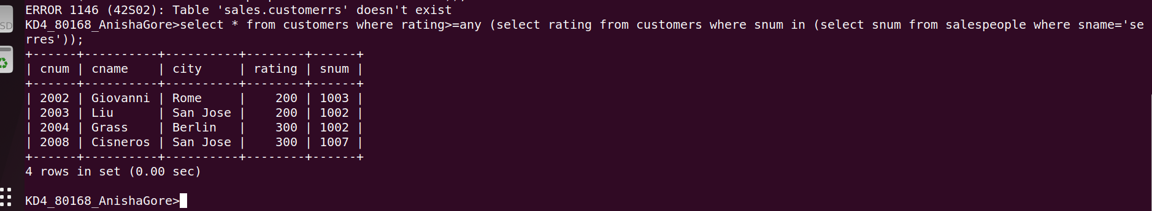
2) Write a query using any or all that will find all salespeople who have no customers located in their city
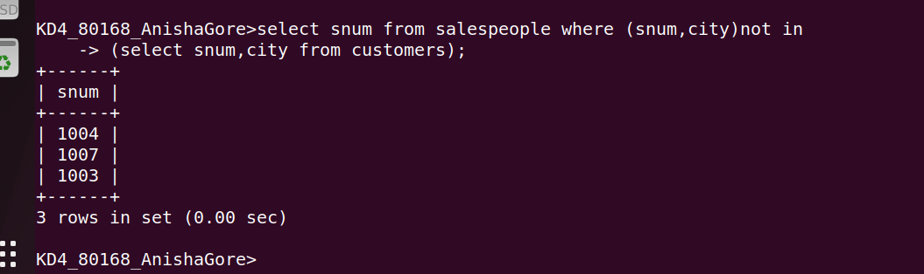
3)write a query that selects all orders for amounts greater than any for the customers in london
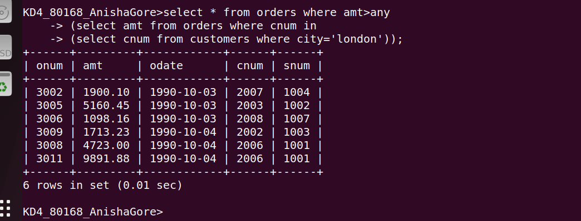

4)write the above query using min or max
