Assignment 14

entering, deleting and changing field values

1)Write a command that puts the following values in their given order , into the salespeople table: city- San Jose, name- Blanco , comm-NULL, cnum -1100
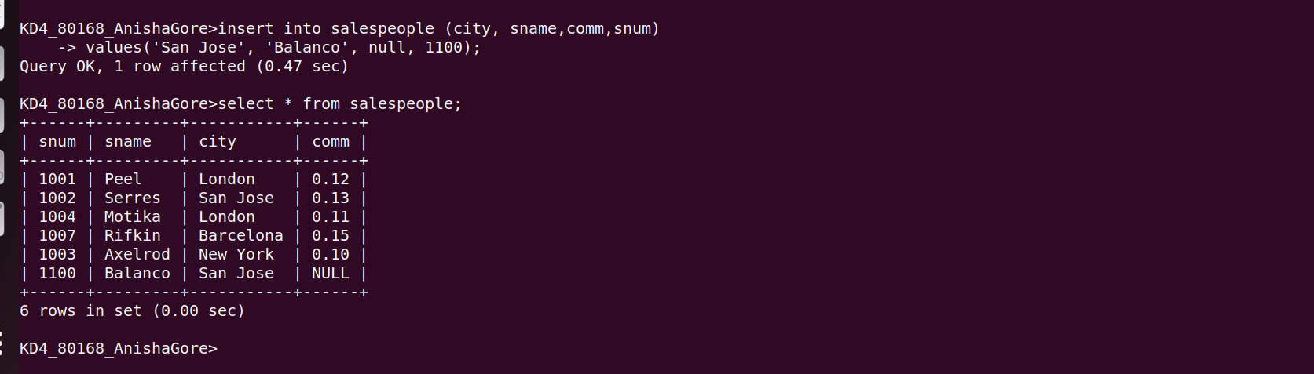

2)Write a command that removes all orders from customers clemens from order table
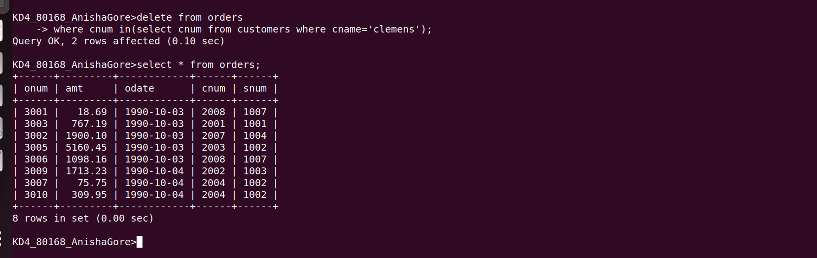

3)Write a command that increases rating of all customers in rome by 100

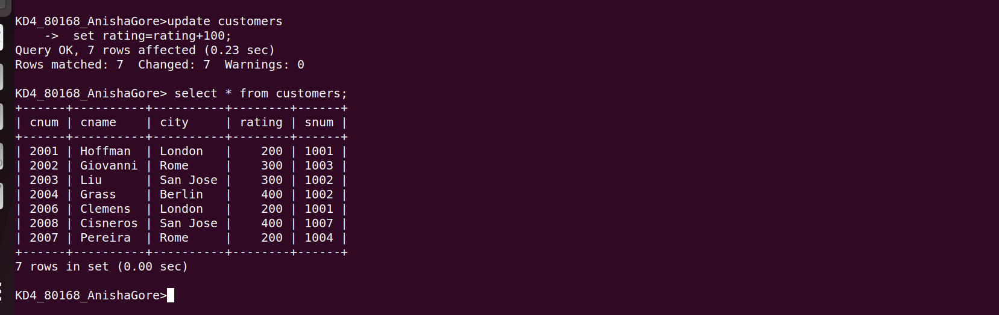

4)Salesperson serres has left the company .Assign her customers to motika.
