Assignment 13

using the union clause

1) create a union of two queries that shows the names, cities and ratings of all customers. Those with rating of 200 or greater will also have the words “High rating”, while the others will have words “low rating”
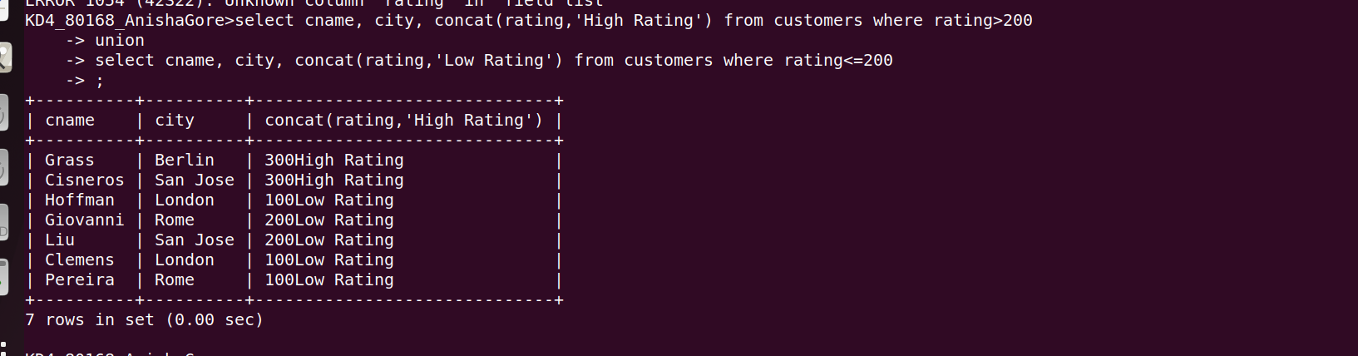

2) Write command that produces the name and number of salesperson and each customer with more than one current order. Put the results in alphabetical order



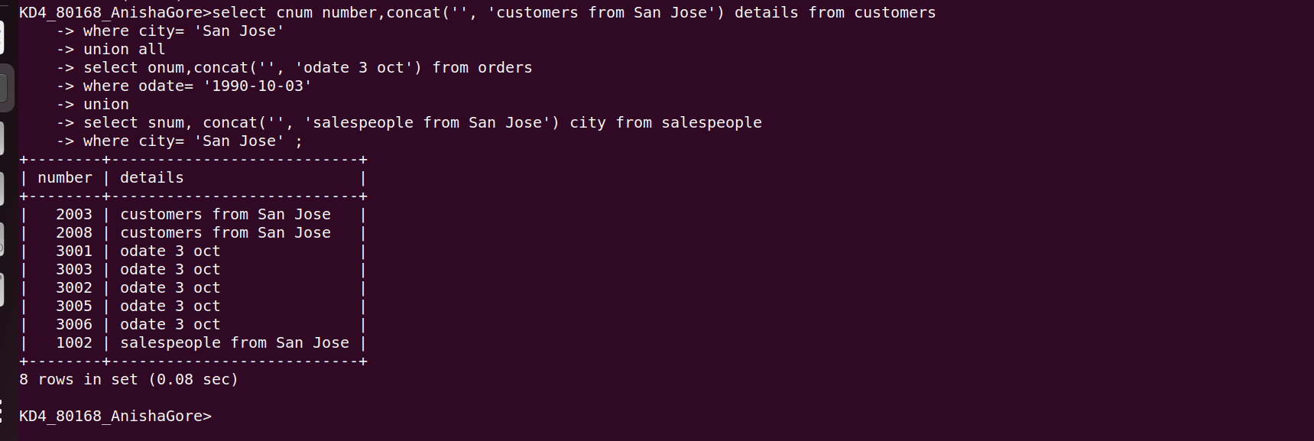
3)form a union of three queries .have the first select the snums of all salespeople in ‘San Jose’ the second , the cnum of all customers in ‘San Jose’ and the third onums of ll ordrs on october 3. retain duplicates between last last two queries but eliminate any redundancies between either of them and the first

