Assignment 8

formatting Query output

1) Assume each salesperson has a 12% commission. write a Query n the orders table that will produce the order number, the salesperson number and the amount of salesperson’s commision for that order.

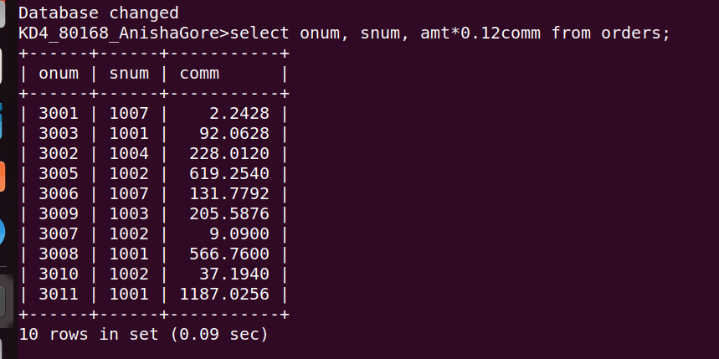

2) Write the query on the customers tble that will find the highest rating in each city. Put the output in the form:
for the city(city), the highest rating is:(rating)

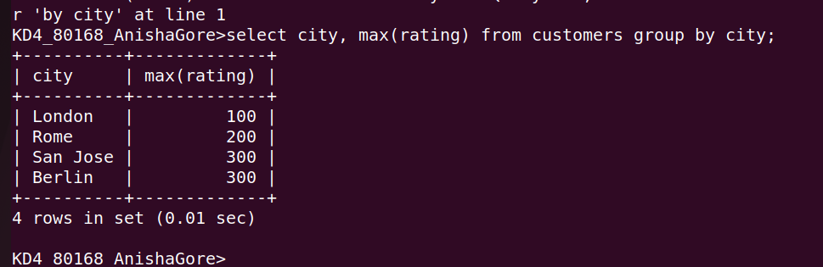

3)Write the query that lists customers in descending order of rating. Output the rating field first , follwed by the customers name and number.

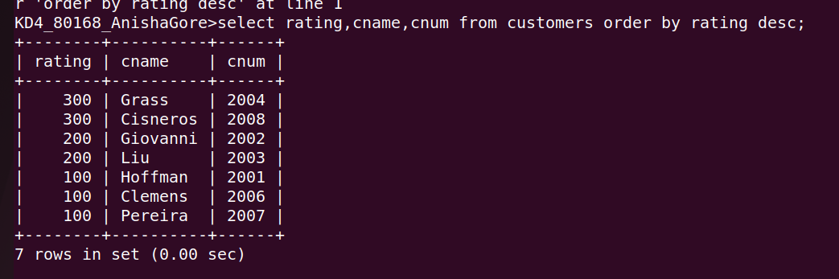

4)Write a query that totals the orders for eachh day and places the result in descending order.
