Assignment 15

using subqueries with DML commands

1)Assume there is a table called Multicast , with all of the same column definitions as salespeople. Write a command that inserts all salespeople with more than one customer into this table.


2)Write a command that deletes all customers with no current orders.
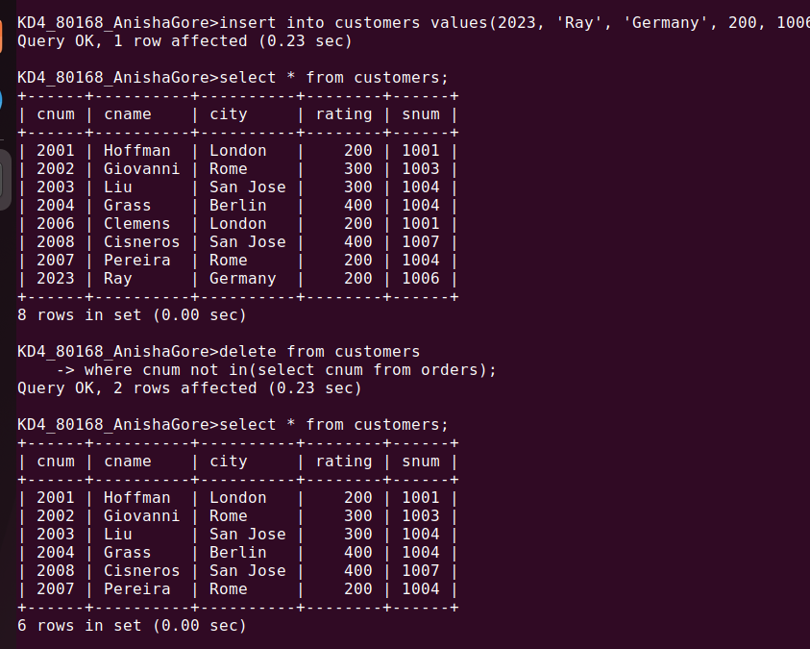

3)Write a command that increases by twenty percent the commisions of all salespeople with total orders above Rs3,000.

