1) Creating sample tables and inserting values.

Create the following table with the given structures and insert data as specified

A) SALESPEOPLE
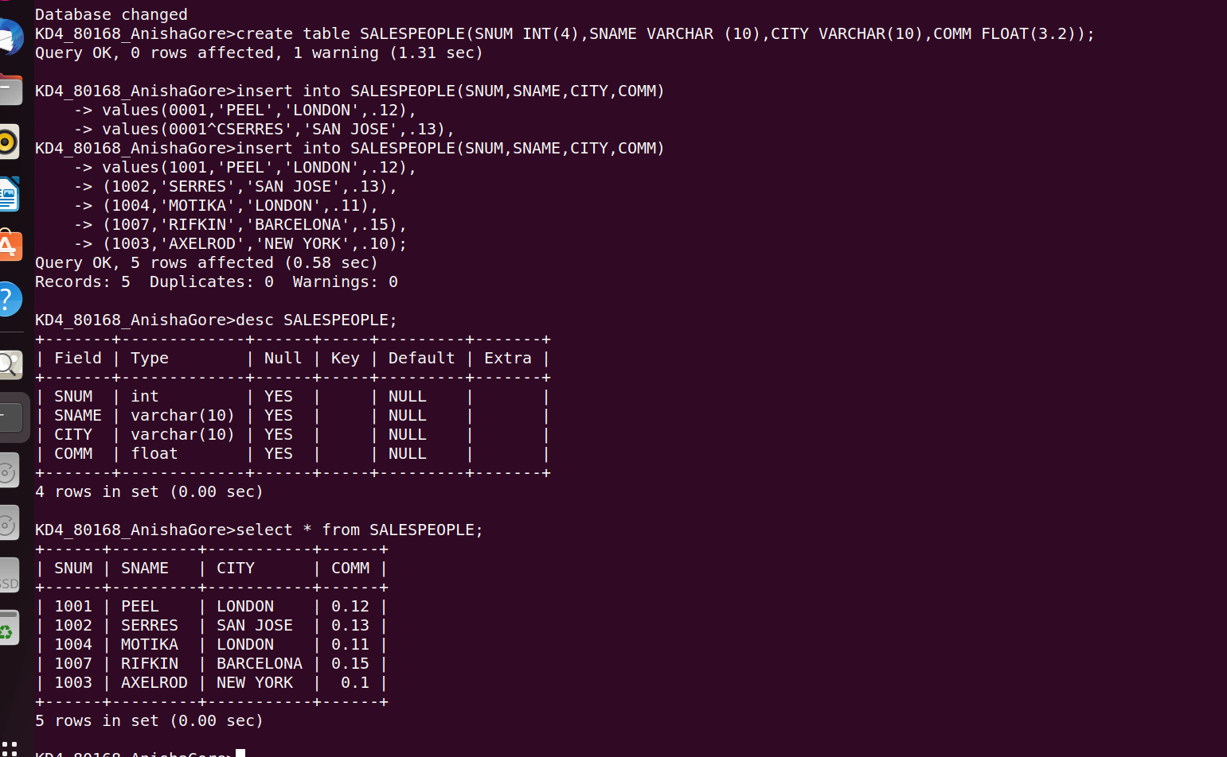

B) CUSTOMERS

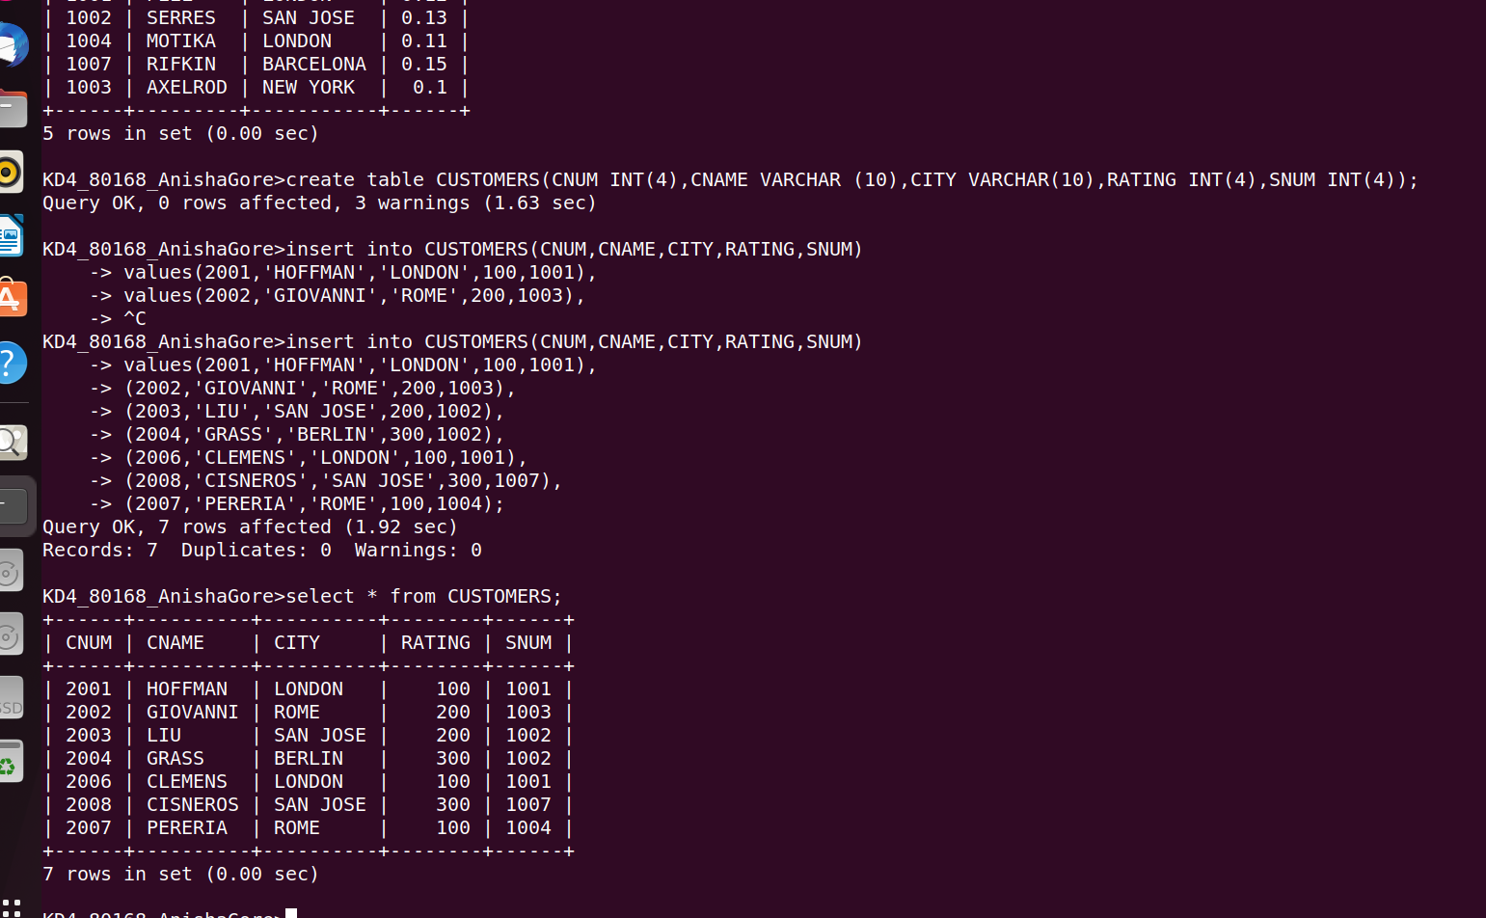

3)ORDERS

