Retrieving information from tables

1) Write a select command that produces the order number , amount , and date for all rows in the orders table
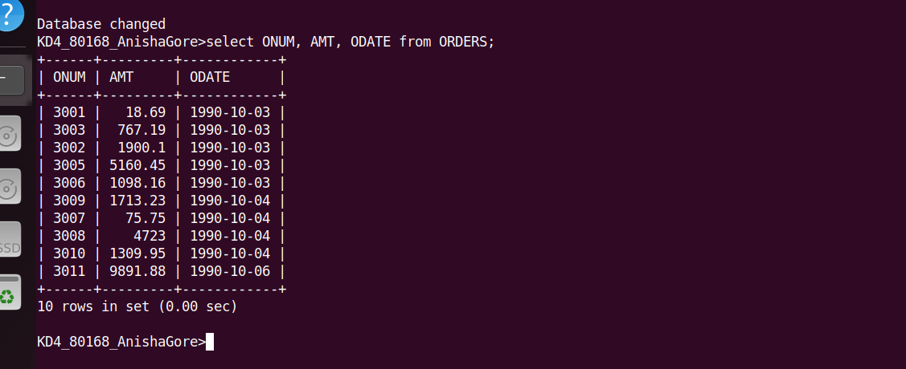
2) Write a query that produces all rows from the customers table from which the SALESPERSONS number is 1001

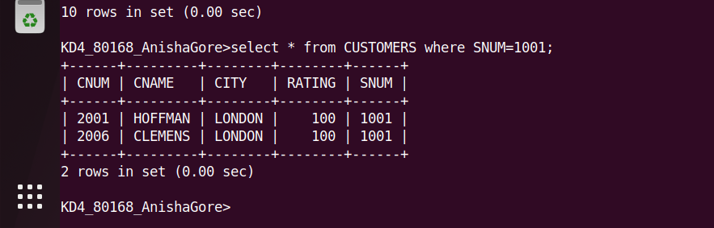

3) Write a query that displays the salespeople table with the columns in the following order:
CITY, SNAME ,SNUM, COMM
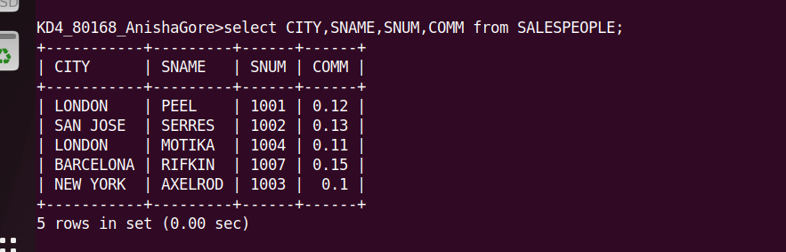

4)Write a slect command that produces the rating followed by the name of each customers in San Jose
