Assignment 9

Querying multiple tables at once

1)Write a query that lists each order number follwed by the name of the cutomer who made the order.
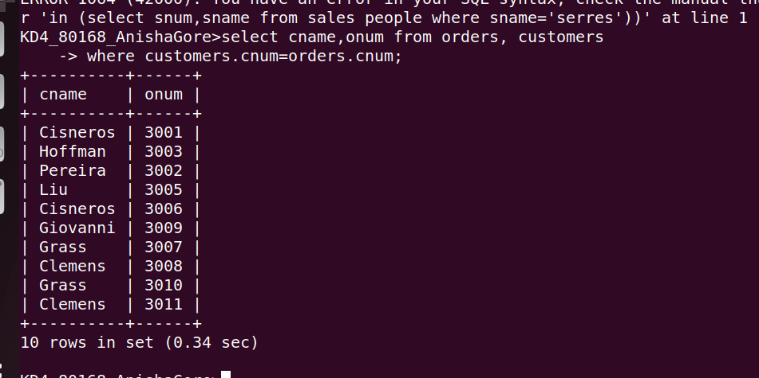
2)Write a query that gives the names of both the salesperson and the customer for each order along with the order number.
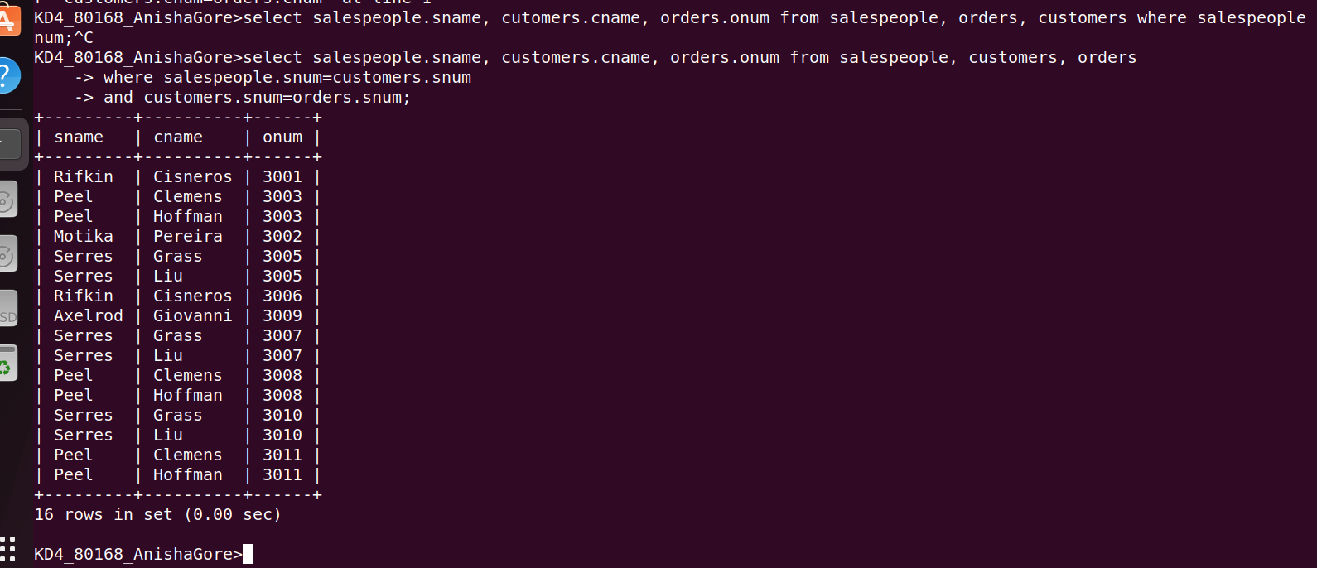

3)Write a query taht produces all customers serviced by salespeople with th commision above 12%. output the customers name, the salesperson name, and the salesperson rate of commision.
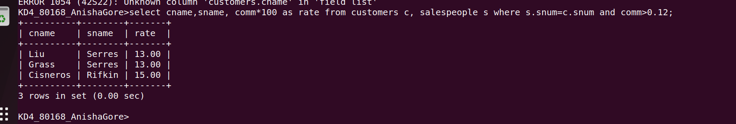
4) Write a query that calculates yhe mount of salespersons commision on each order by a customer with rating above 100.

