Assignment 7

Summarizing Data with Aggregate functions

1)Write a query that counts all orders for october3.

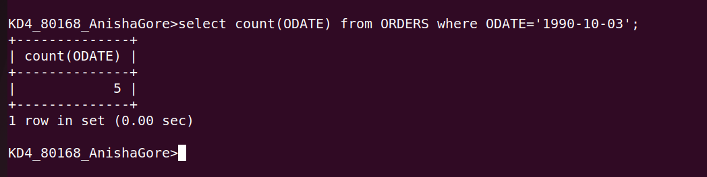

2)Write a query that counts the number of different non-NULL city values in the customers table.

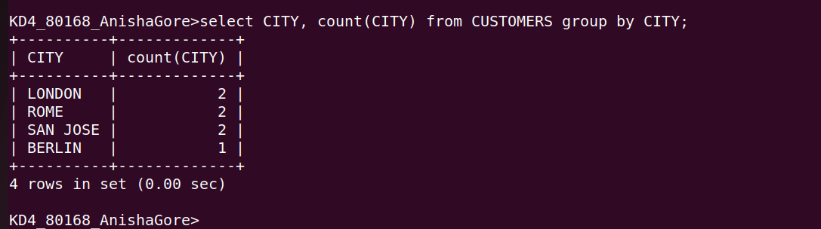
3)Write a query that selects each customers smallest number
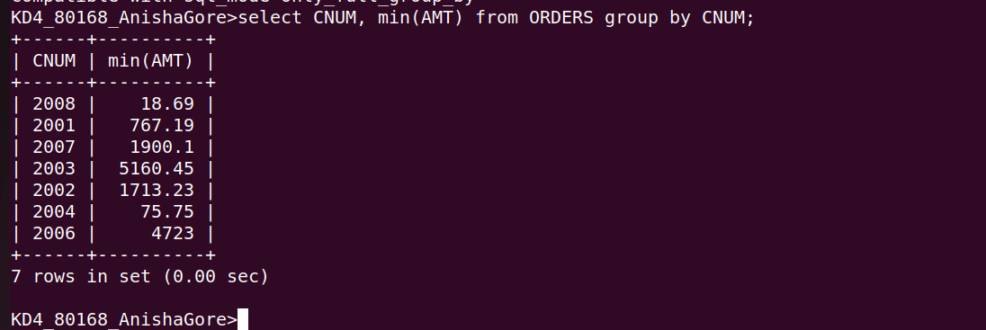

4) Write a query that selects the first customer in alphabitical order , whose name begins with G
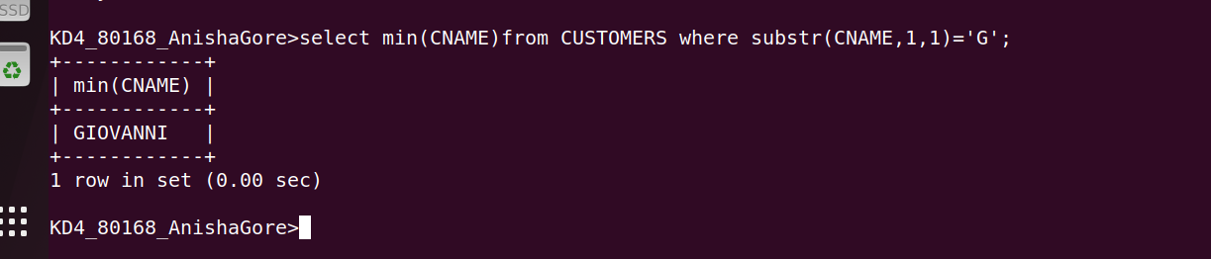
5)Write a query that selects the hightest rating in each city.

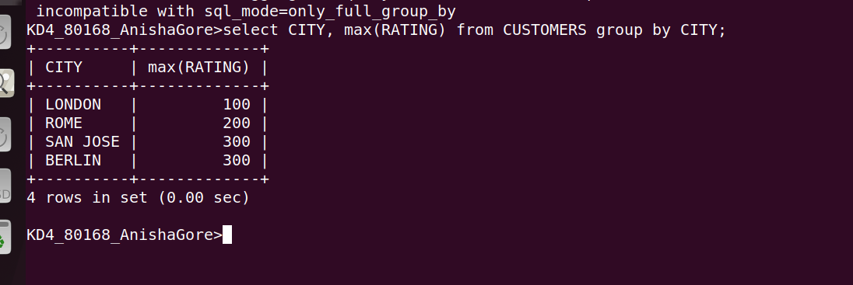
6) Write a query that counts the number of salespeople registering orders for each day.
