Assignment 10

Joining a table to itself.

1)Write a query that produces all pairs of salespeople who are living in the same city. Exclude combinations of saesperson with themselves as well as duplicate rows with the order reversed.
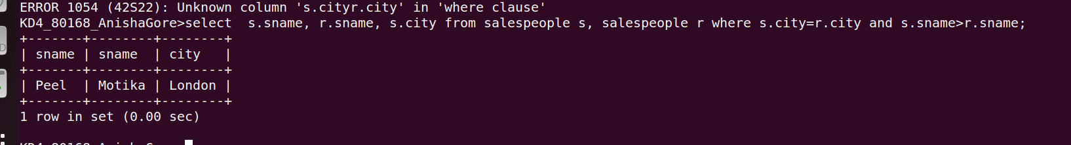

2) Write a query that produce the names and cities of all customers with the same rating as hoffman.


