Assignment 5

Relational and logical operators

1) Write a query that will give you all orders for more than Rs.1,000

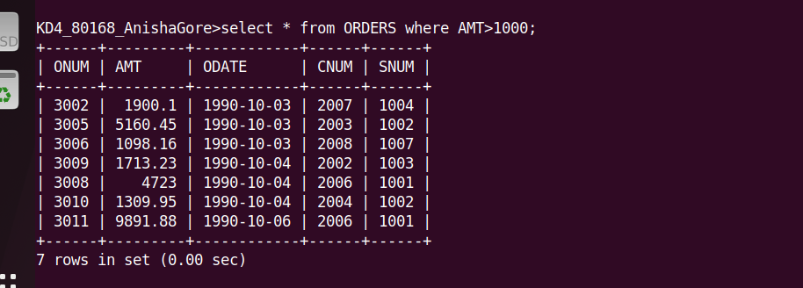

2) Write a query that will give you the names and cities of all salespeople in London with a commision above .10

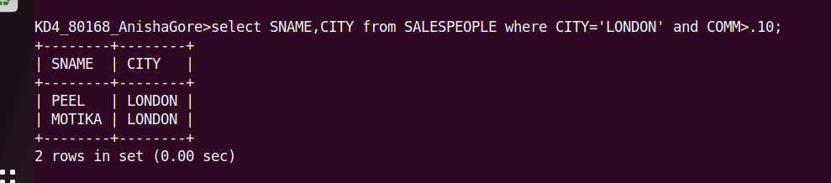

3) Write a query on the customers table whose output will exclude all the customers with a rating<=100,unless they are located in ROME
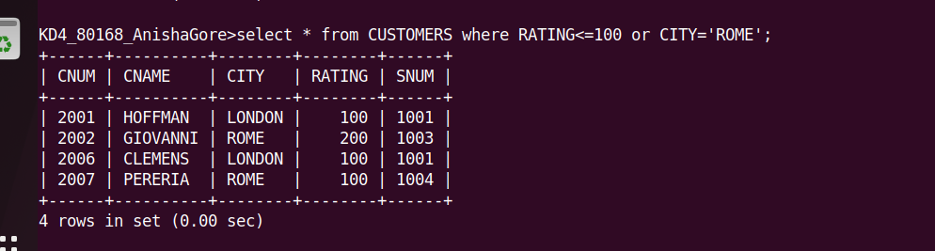

4) What will be the output from the following query?
Select * from orders
where (amt<1000 OR
NOT (odate =’1990-10-03’ AND cnum>2003));

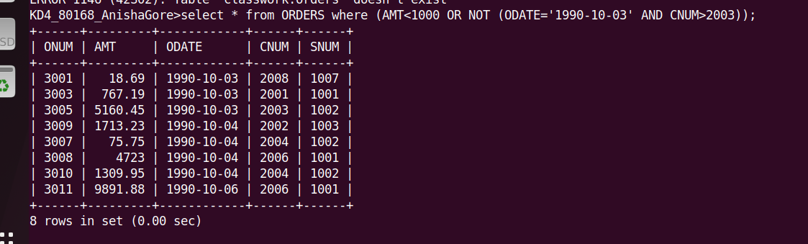

5)What will be the output from the following query?
Select * from orders
where NOT ((odate =’1990-10-03’ OR snum >1006)
AND amt>= 1500);

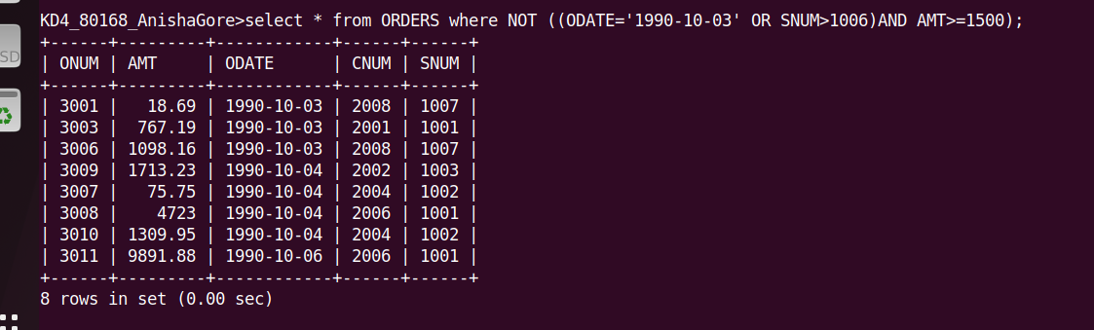

6)What is a simpler way to write a query?
Select snum,sname,city,comm from salespeople where (comm>.12 OR comm<.14);

